# GRAPHICAL USER INTERFACE DESIGN

**User Interface/Report Number: 001**



**Home Page**



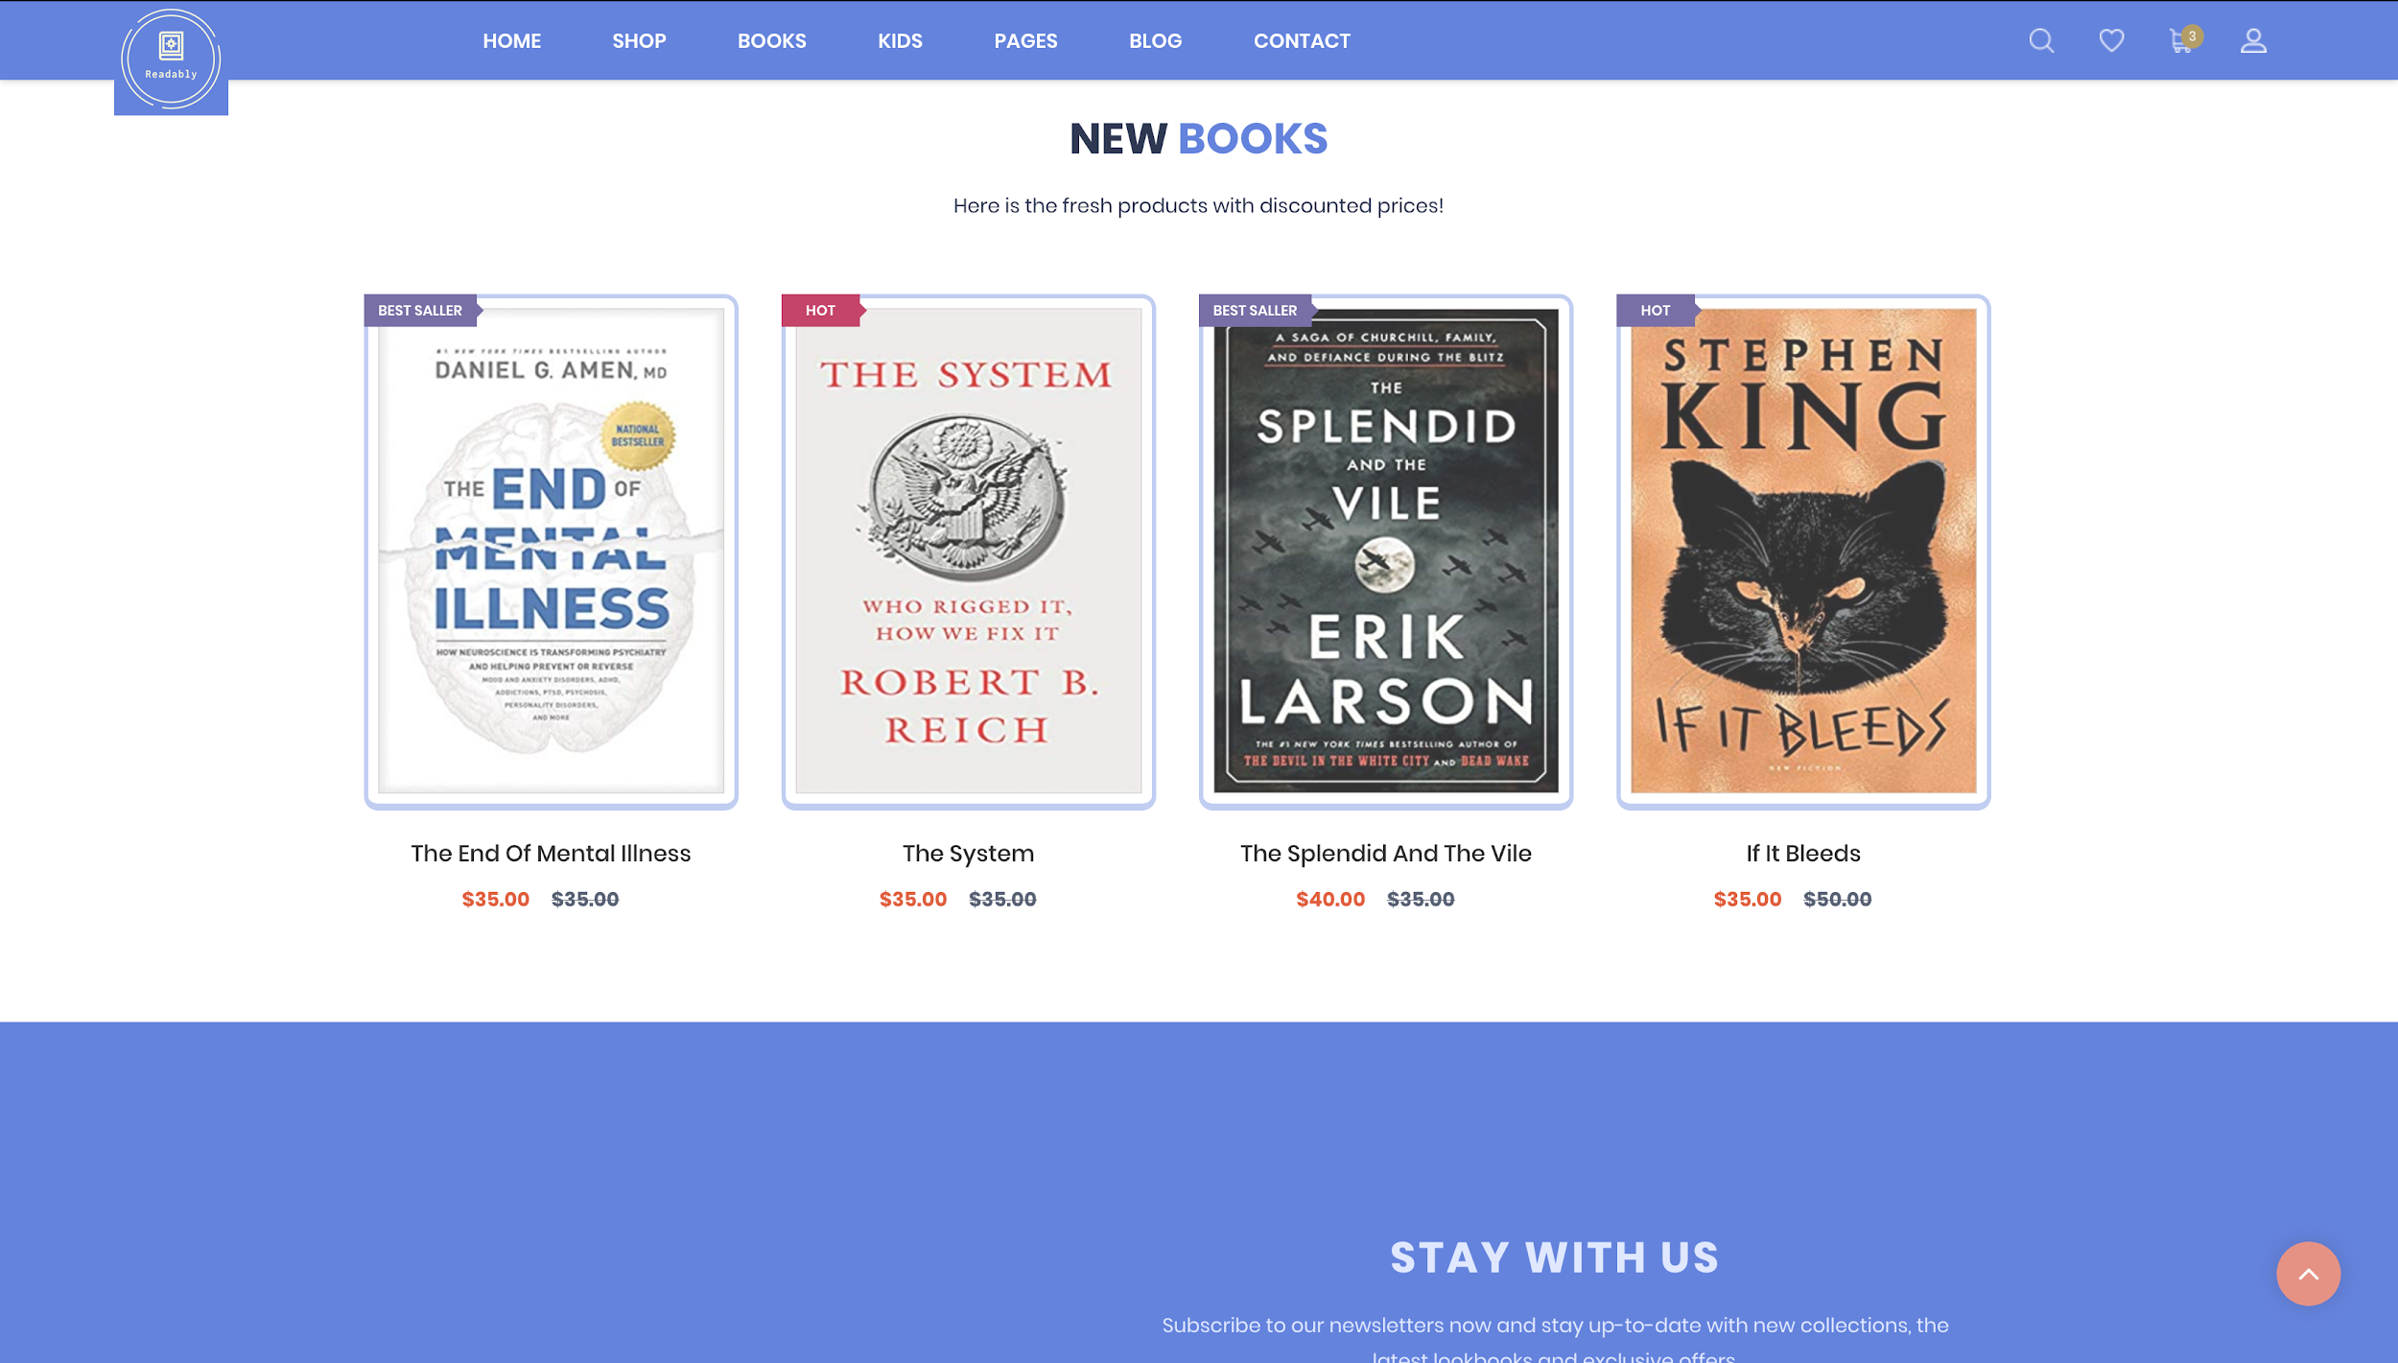

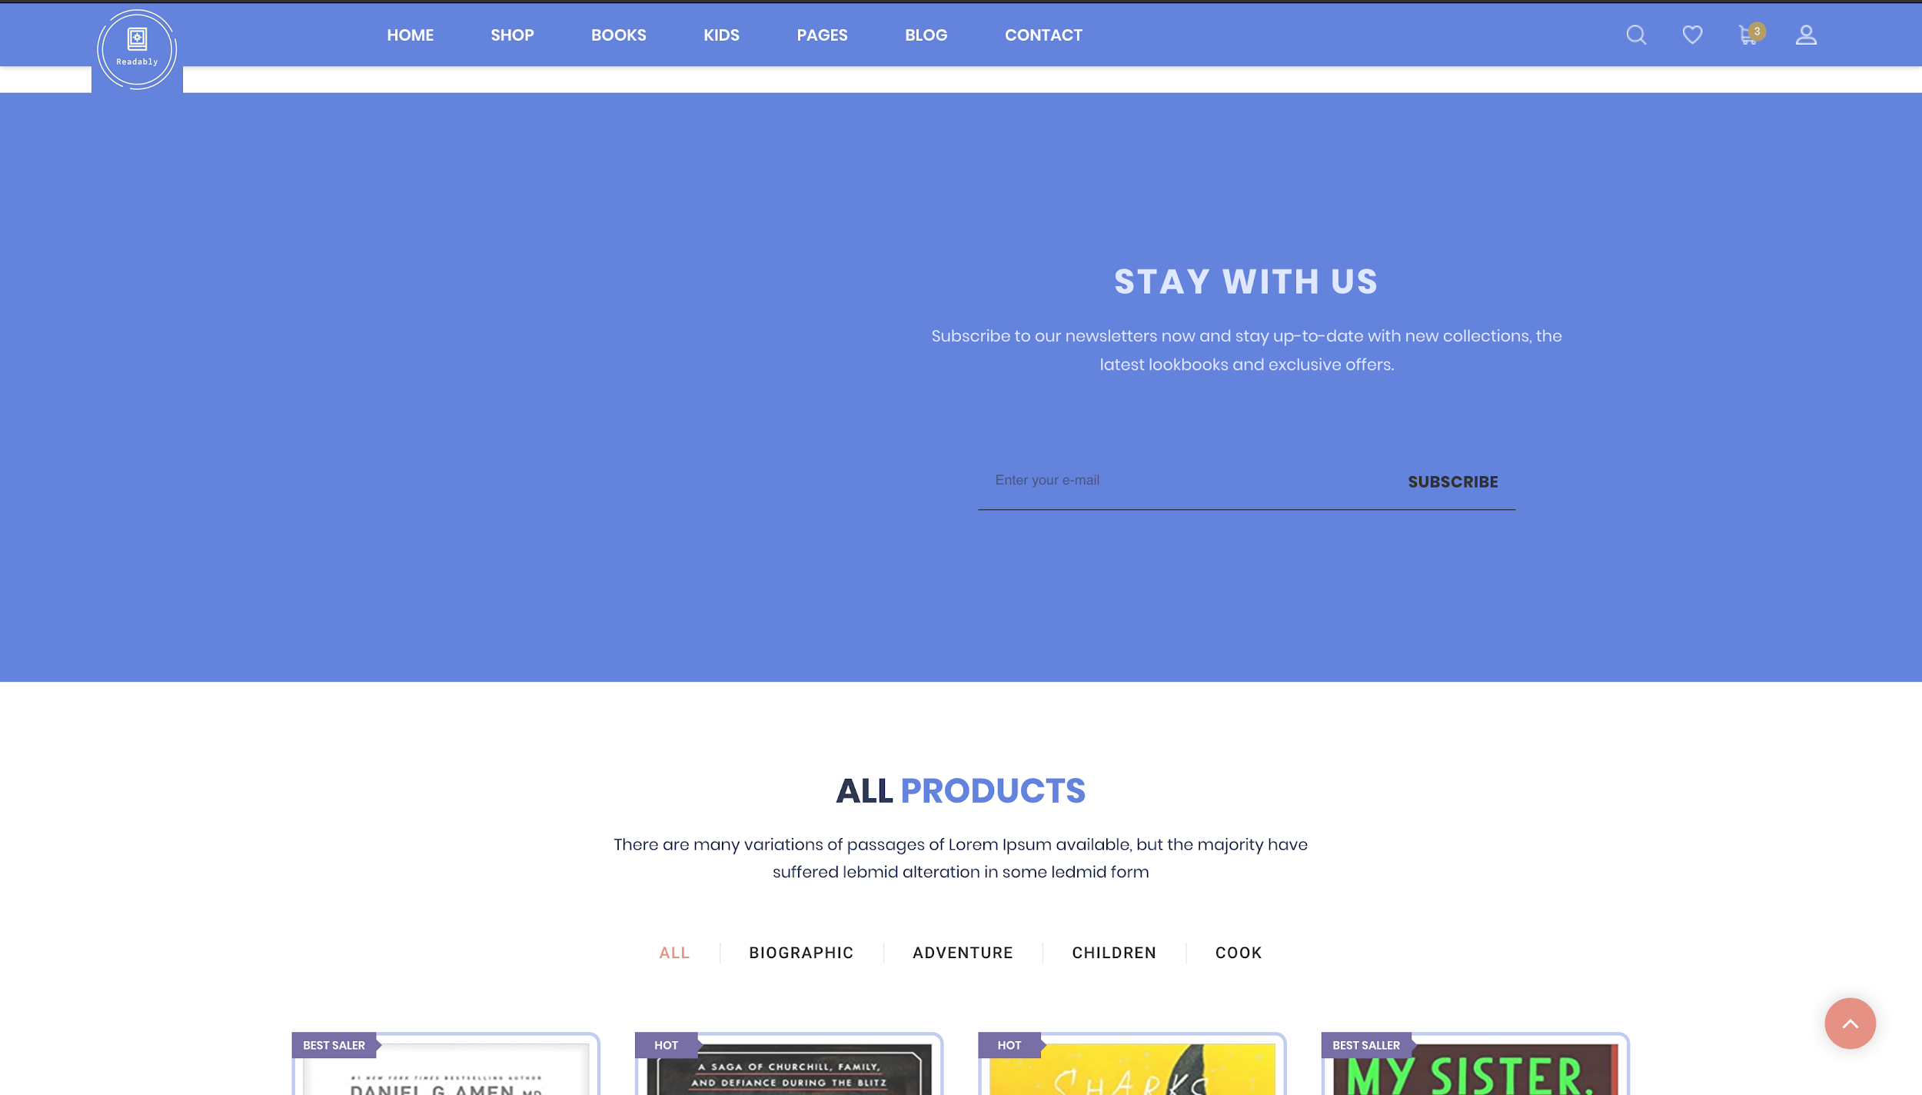

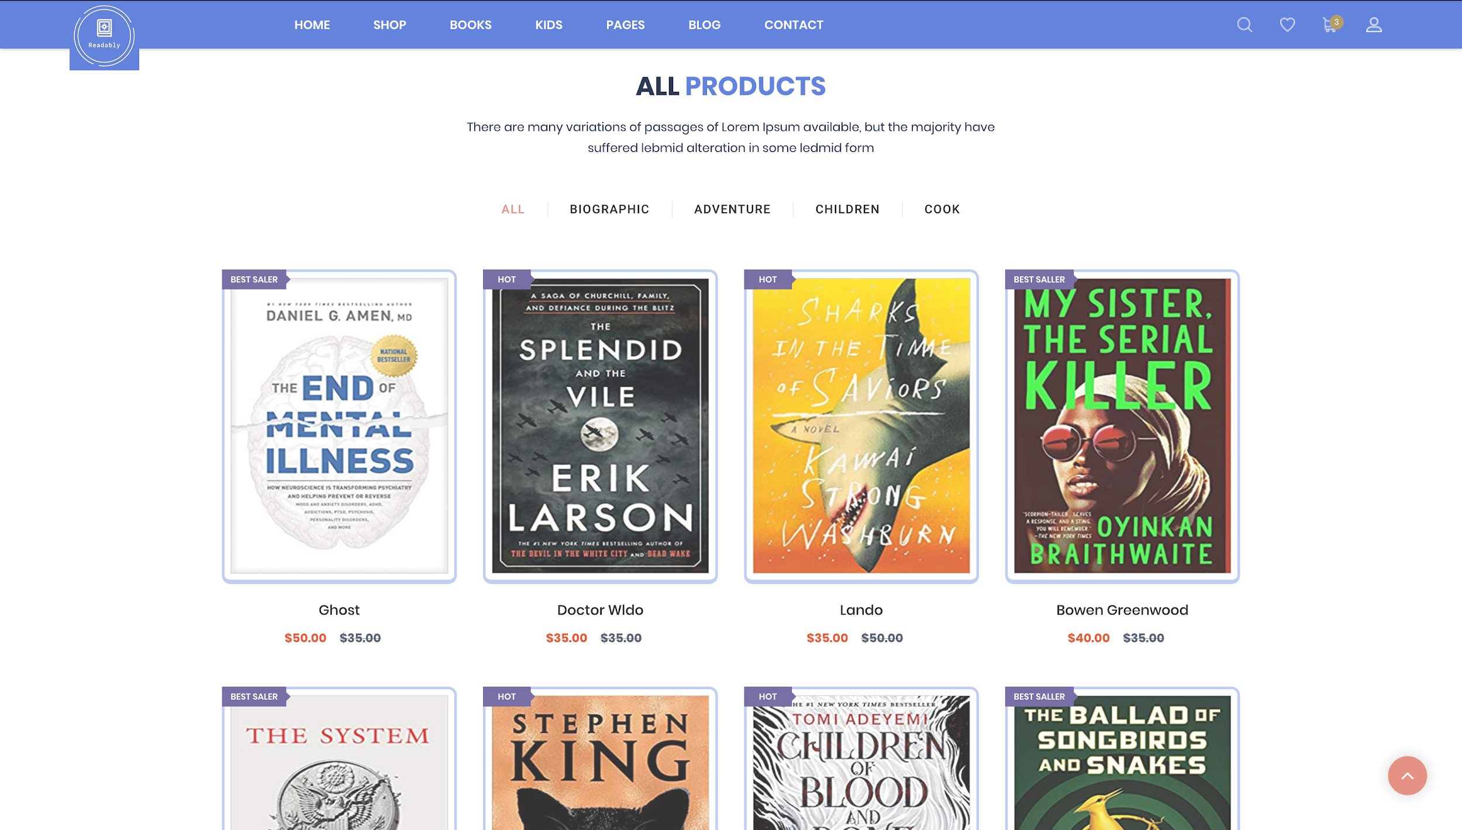

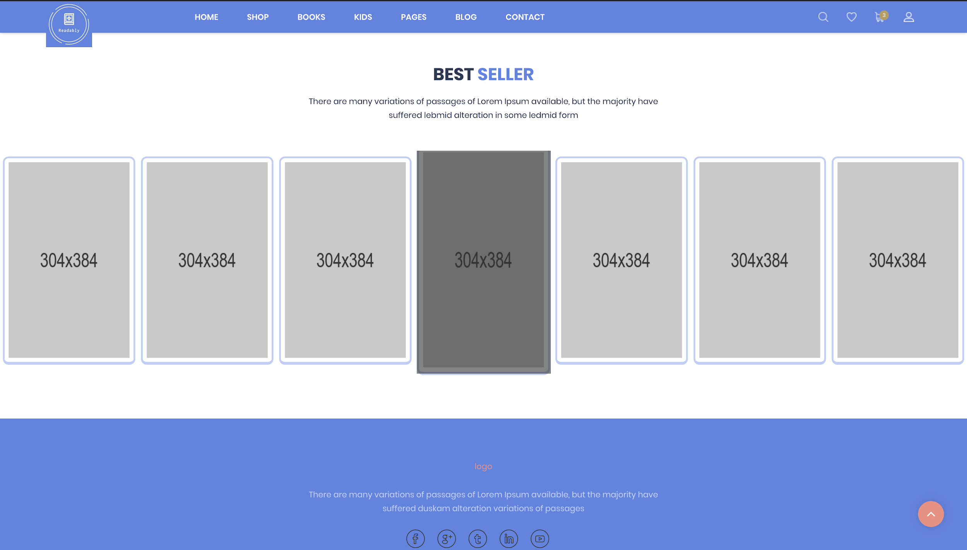

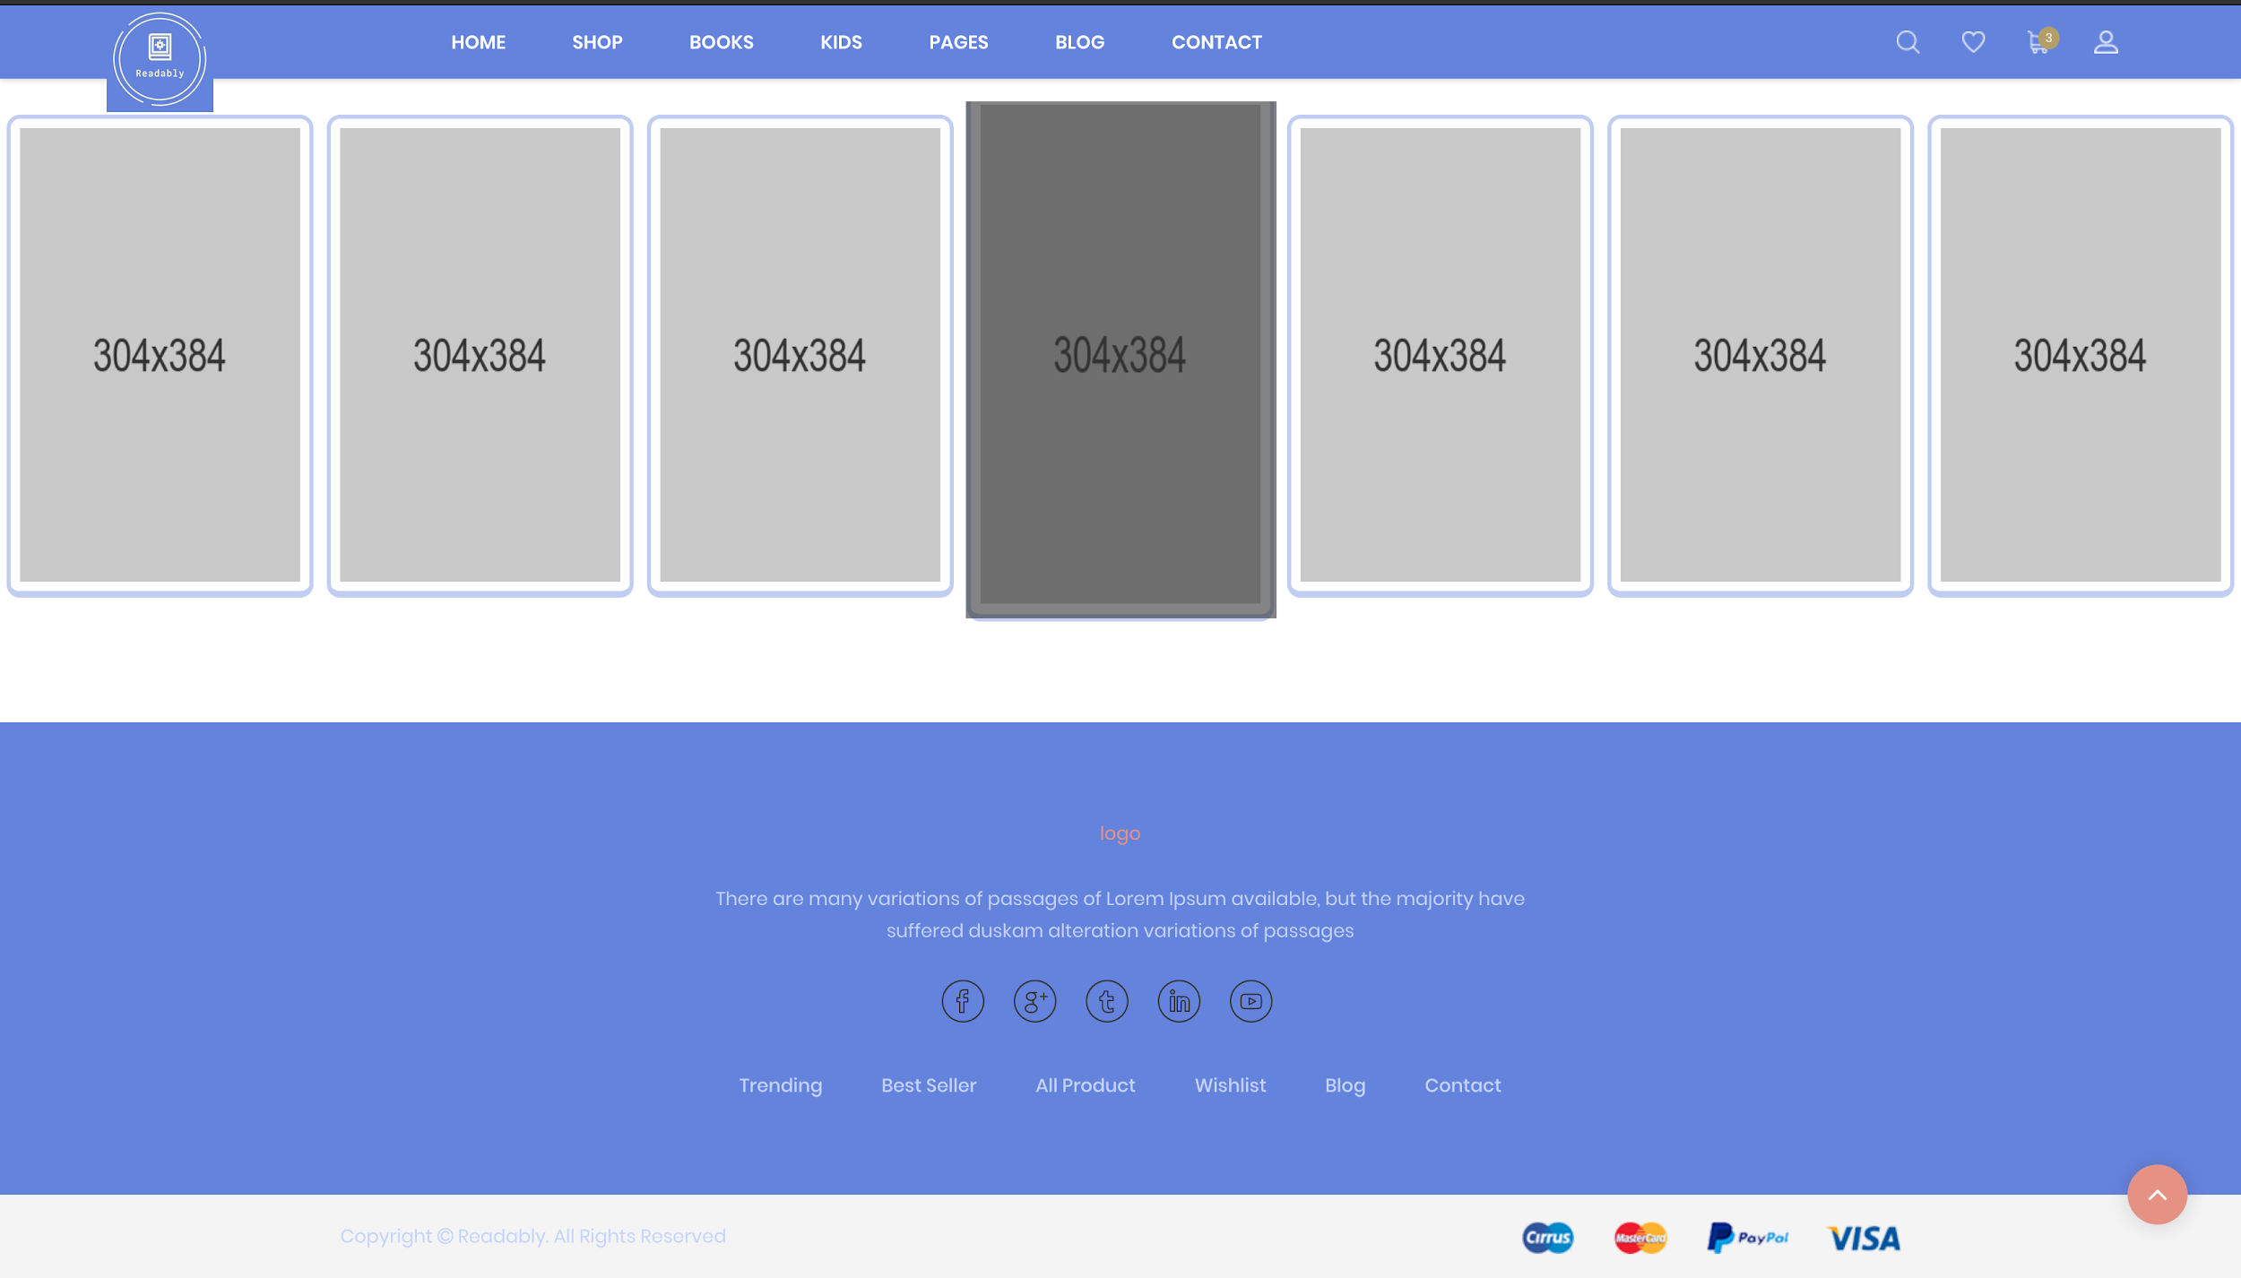

**User Interface/Report Number: 002**

**Related Use-Case: OBS-UC-001 (Login) / BOBS-UC-003 (Registering)**



**Login / Register Page**

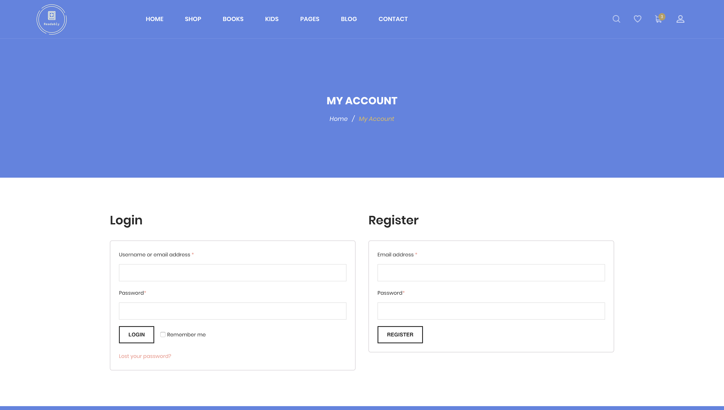

**User Interface/Report Number: 003**

**Related Use-Case:**



**Checkout Page**

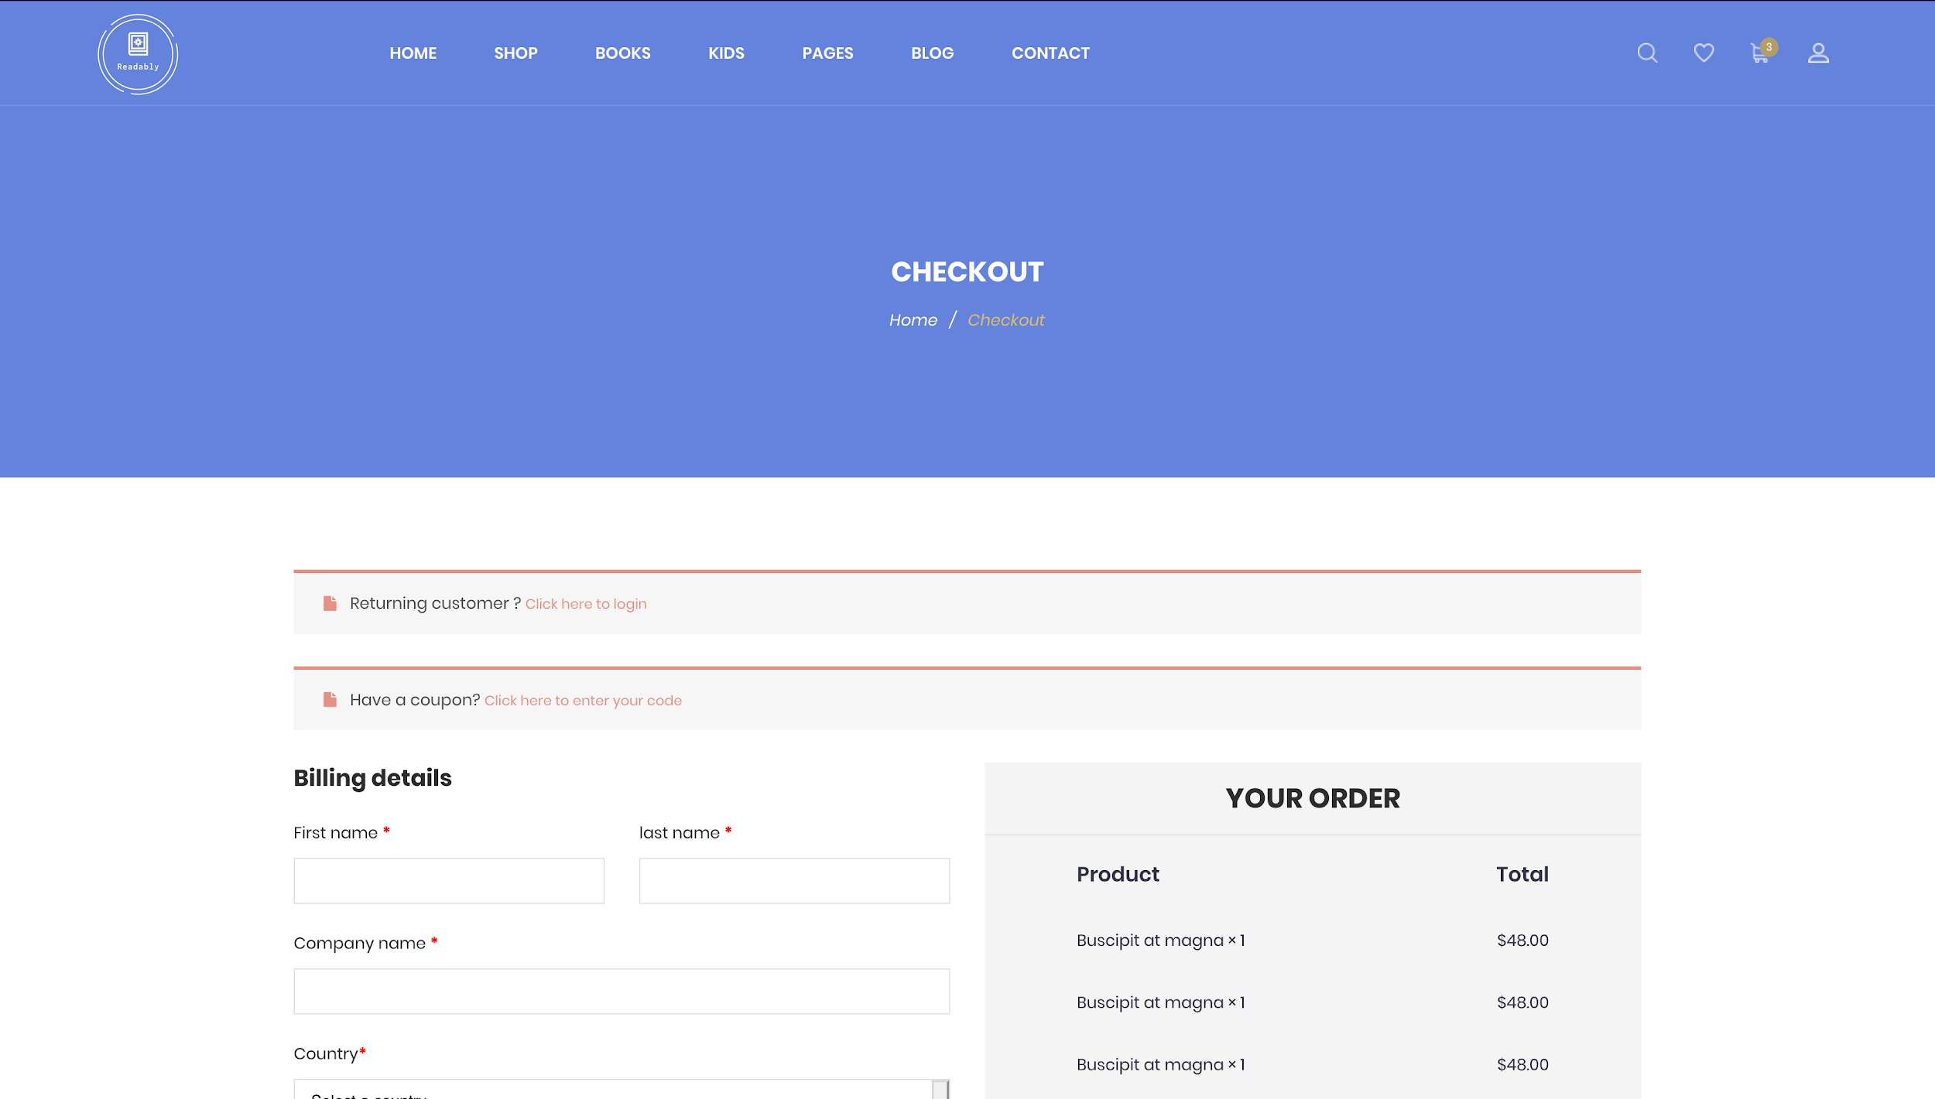

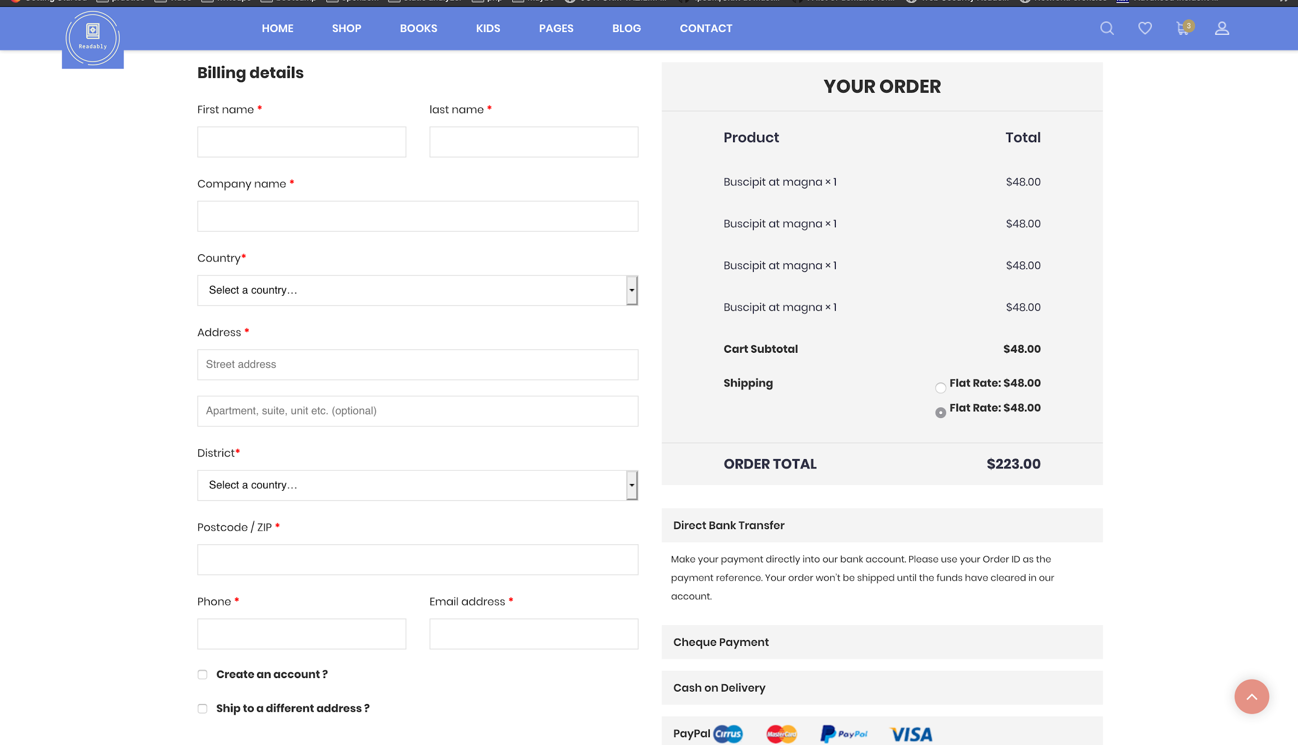

**User Interface/Report Number: 004**

**Related Use-Case:OBS-UC-005(Shopping Card)**



**Shopping Cart Page**

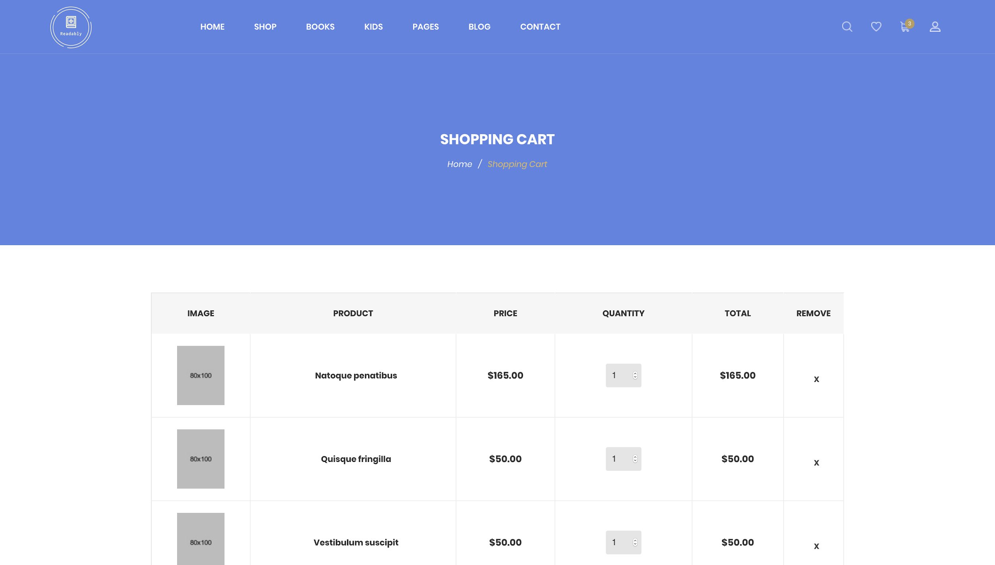

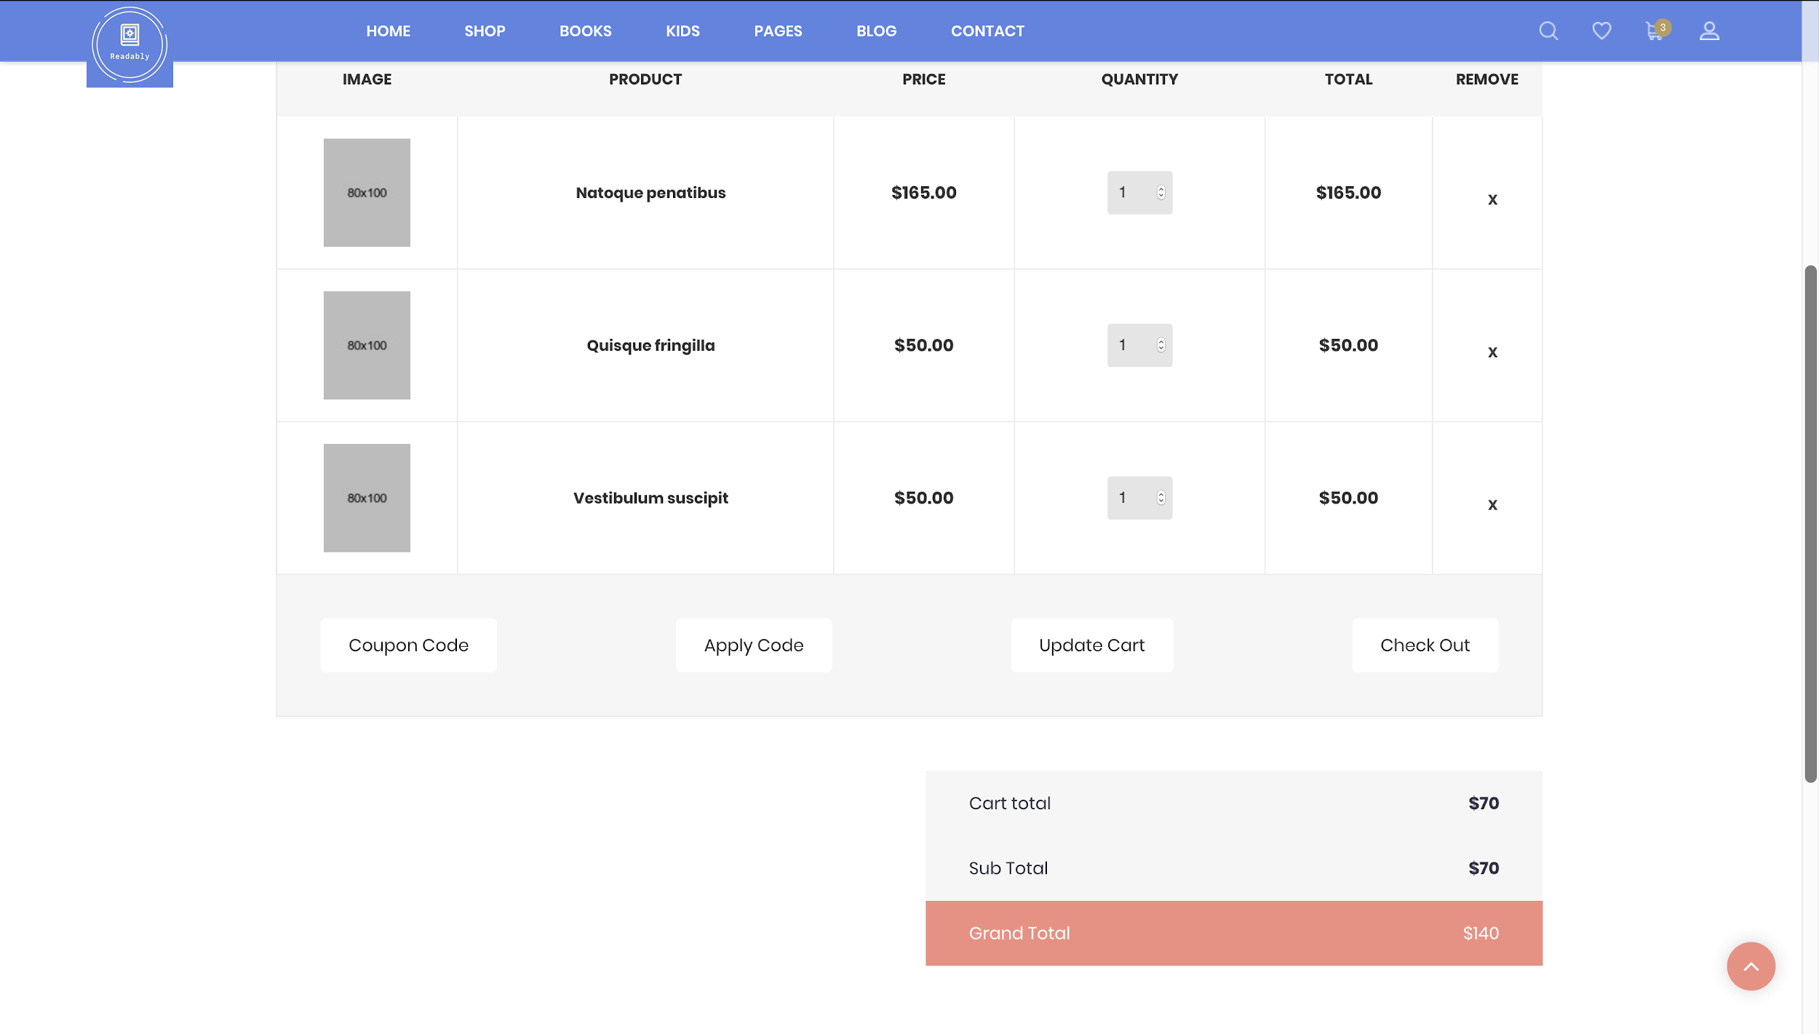

**User Interface/Report Number: 005**

**Related Use-Case: OBS-UC-012 (Contact)**



**Contact Page**

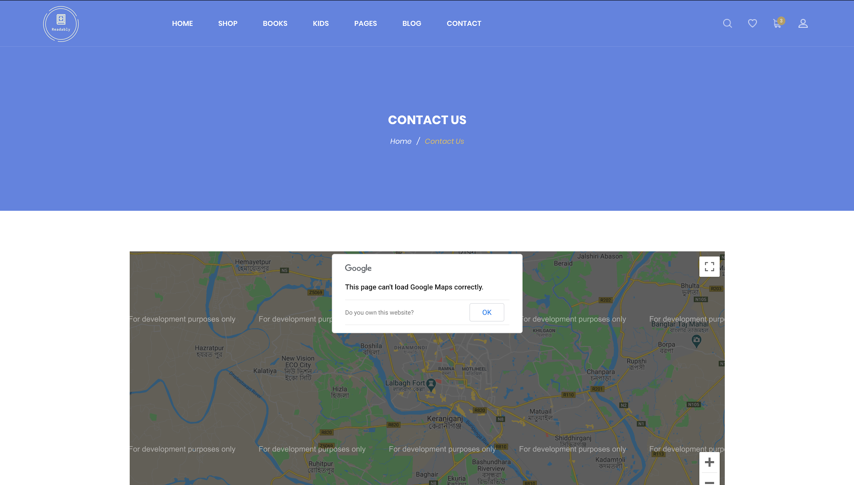

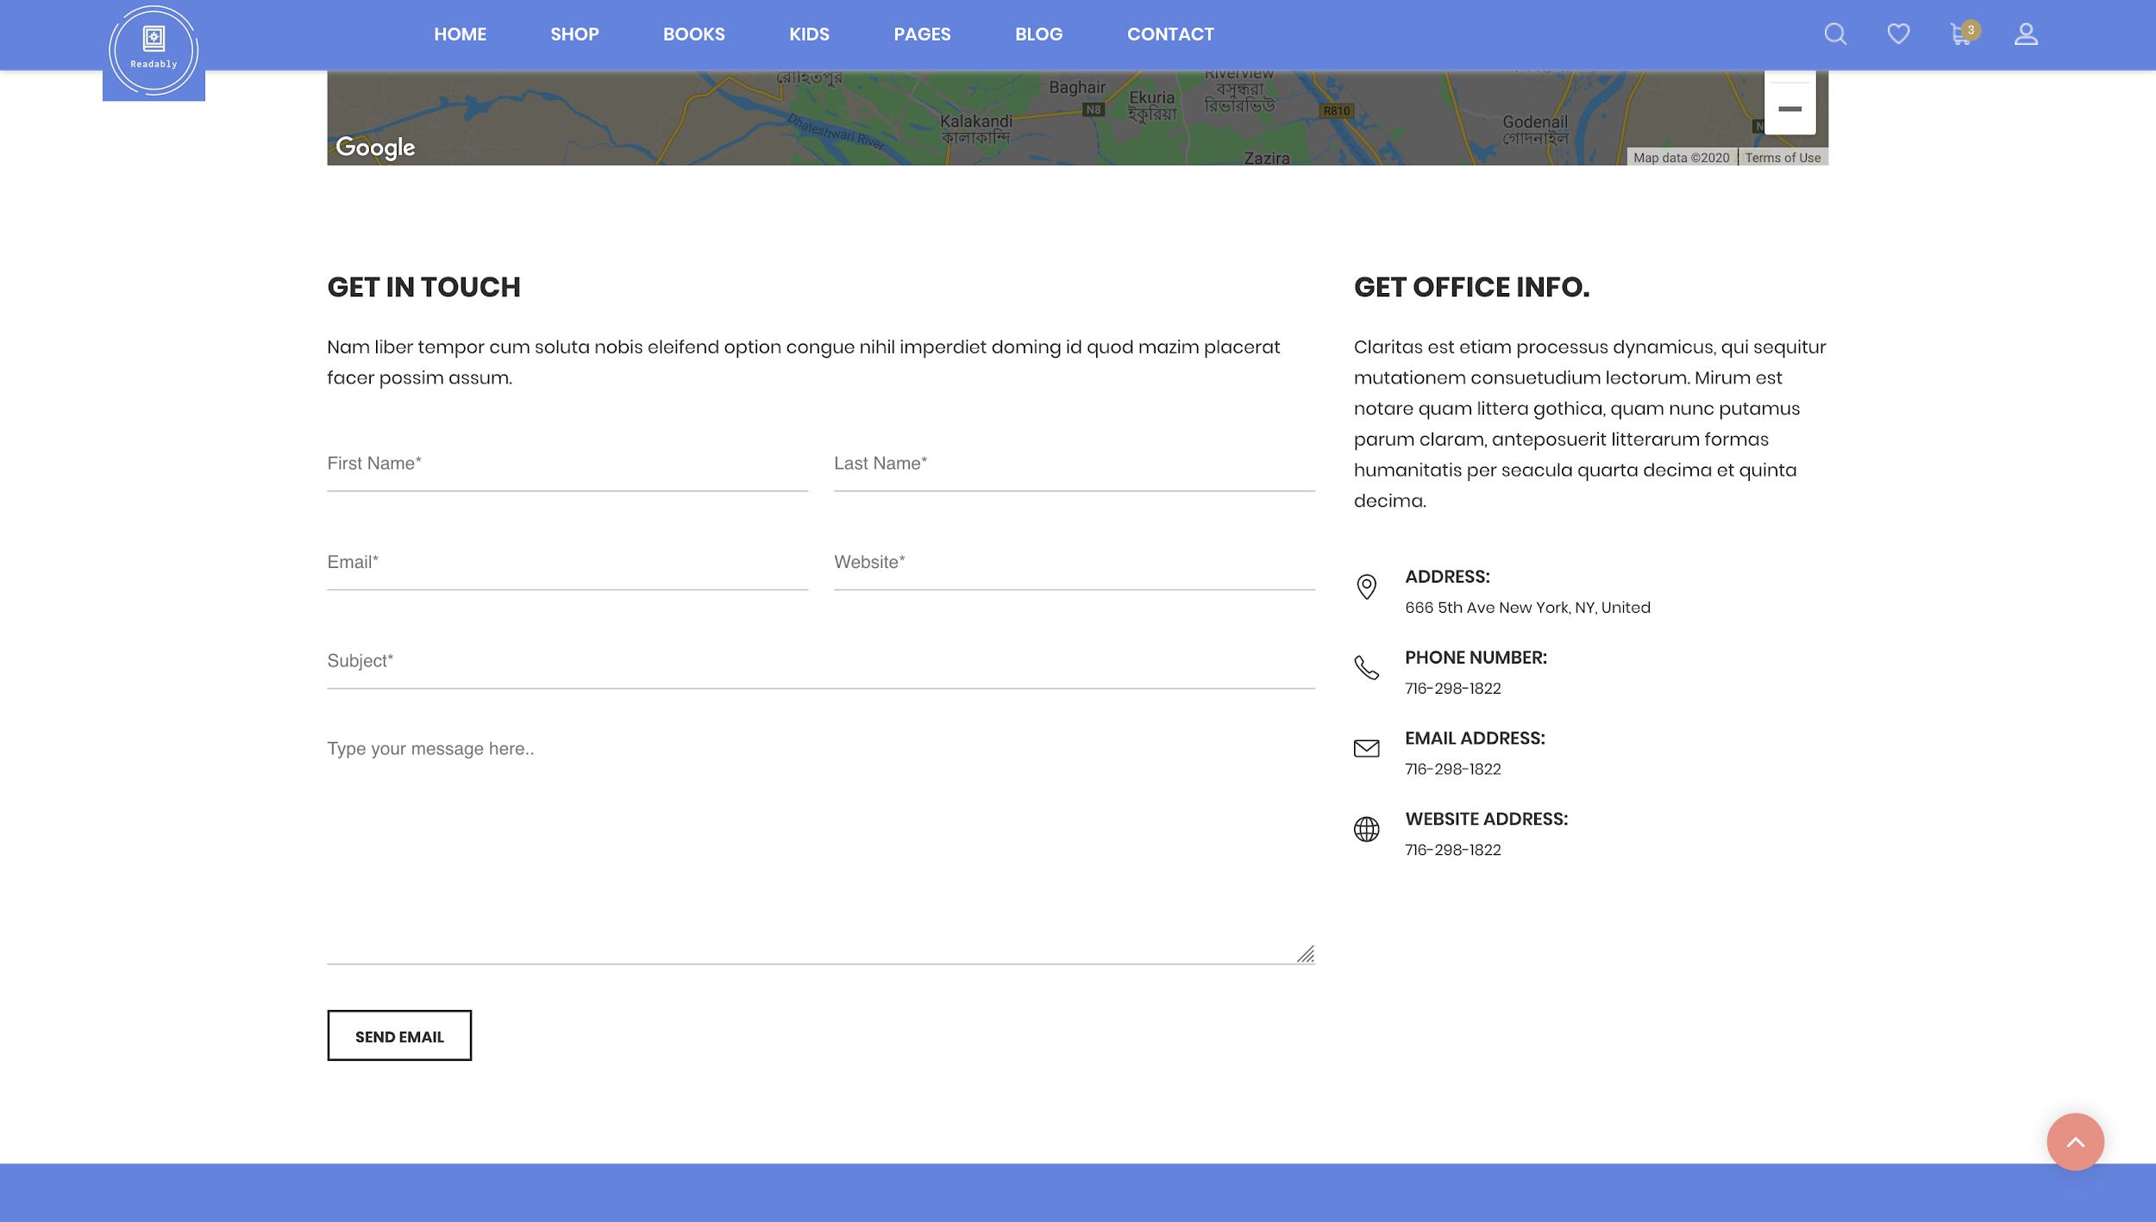

**User Interface/Report Number: 006**



**404 Error Page**

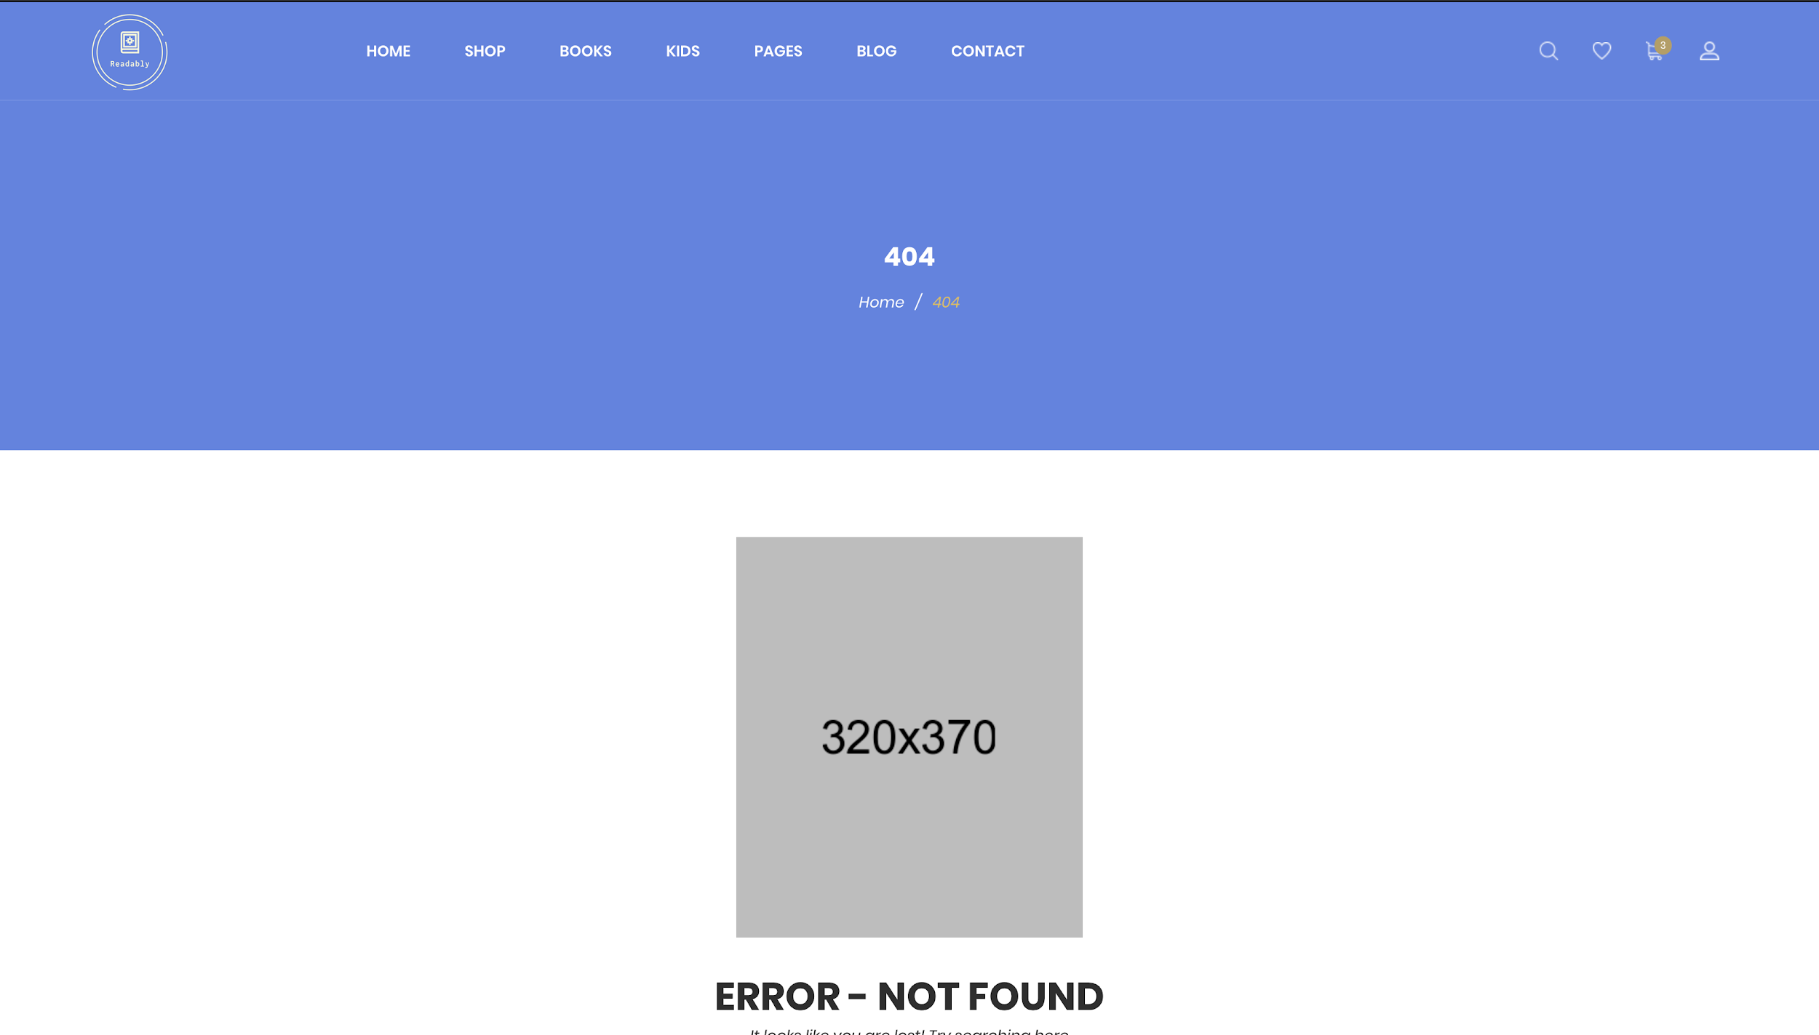

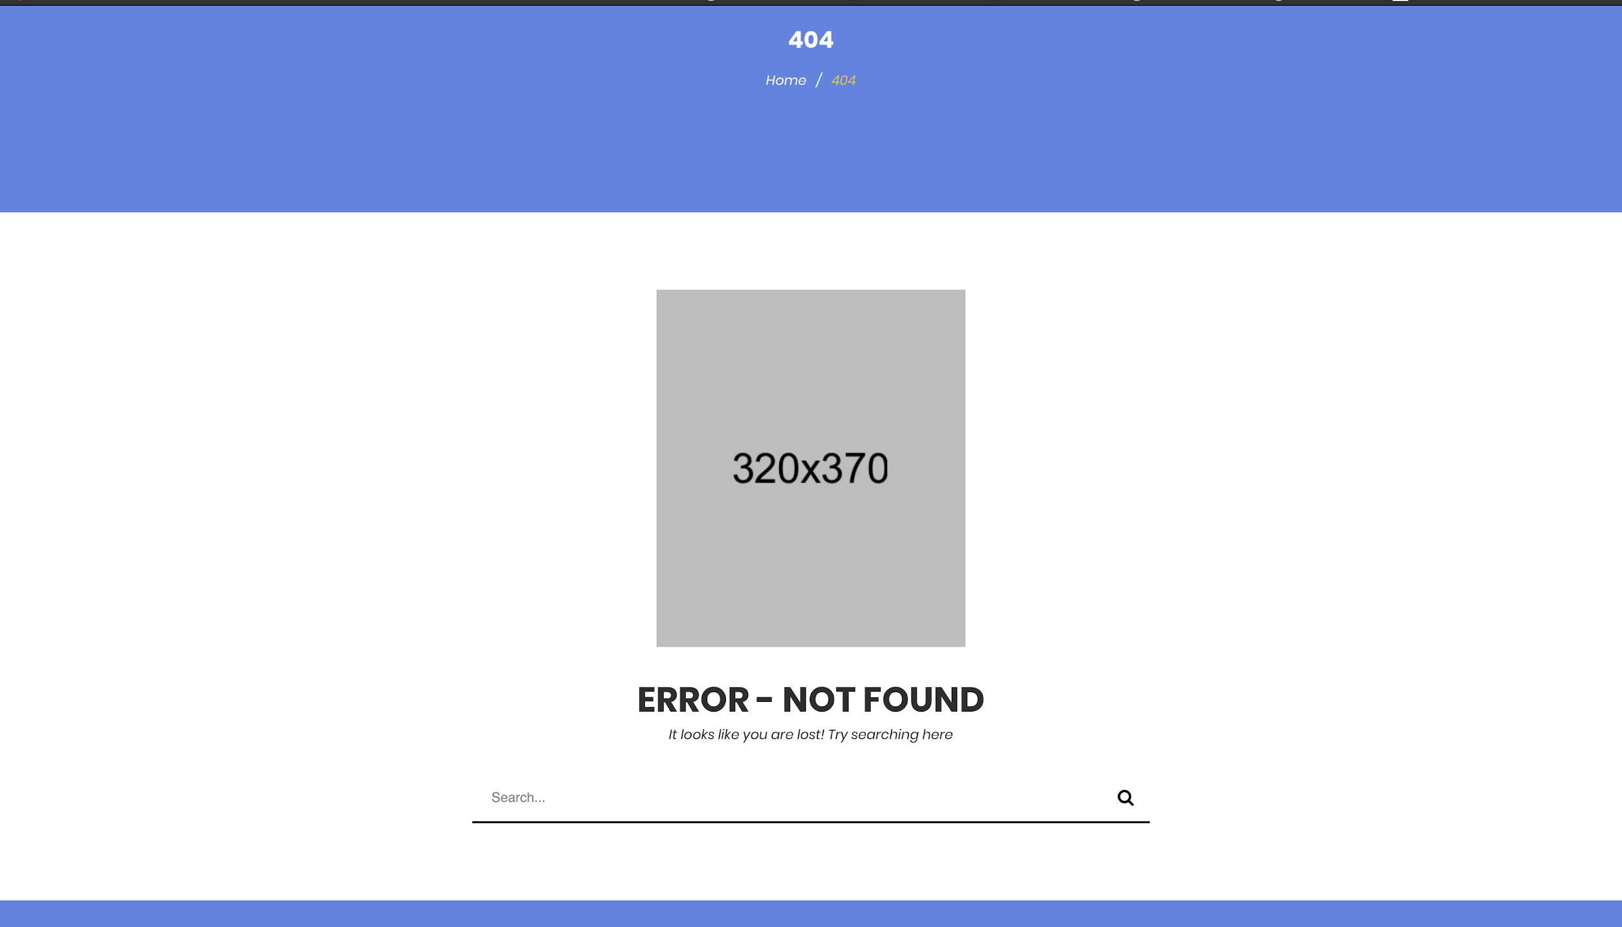

**User Interface/Report Number: 007**

**Related Use-Case:OBS-UC-012(Contact)**



**Frequently Asked Questions (FAQ) Page**

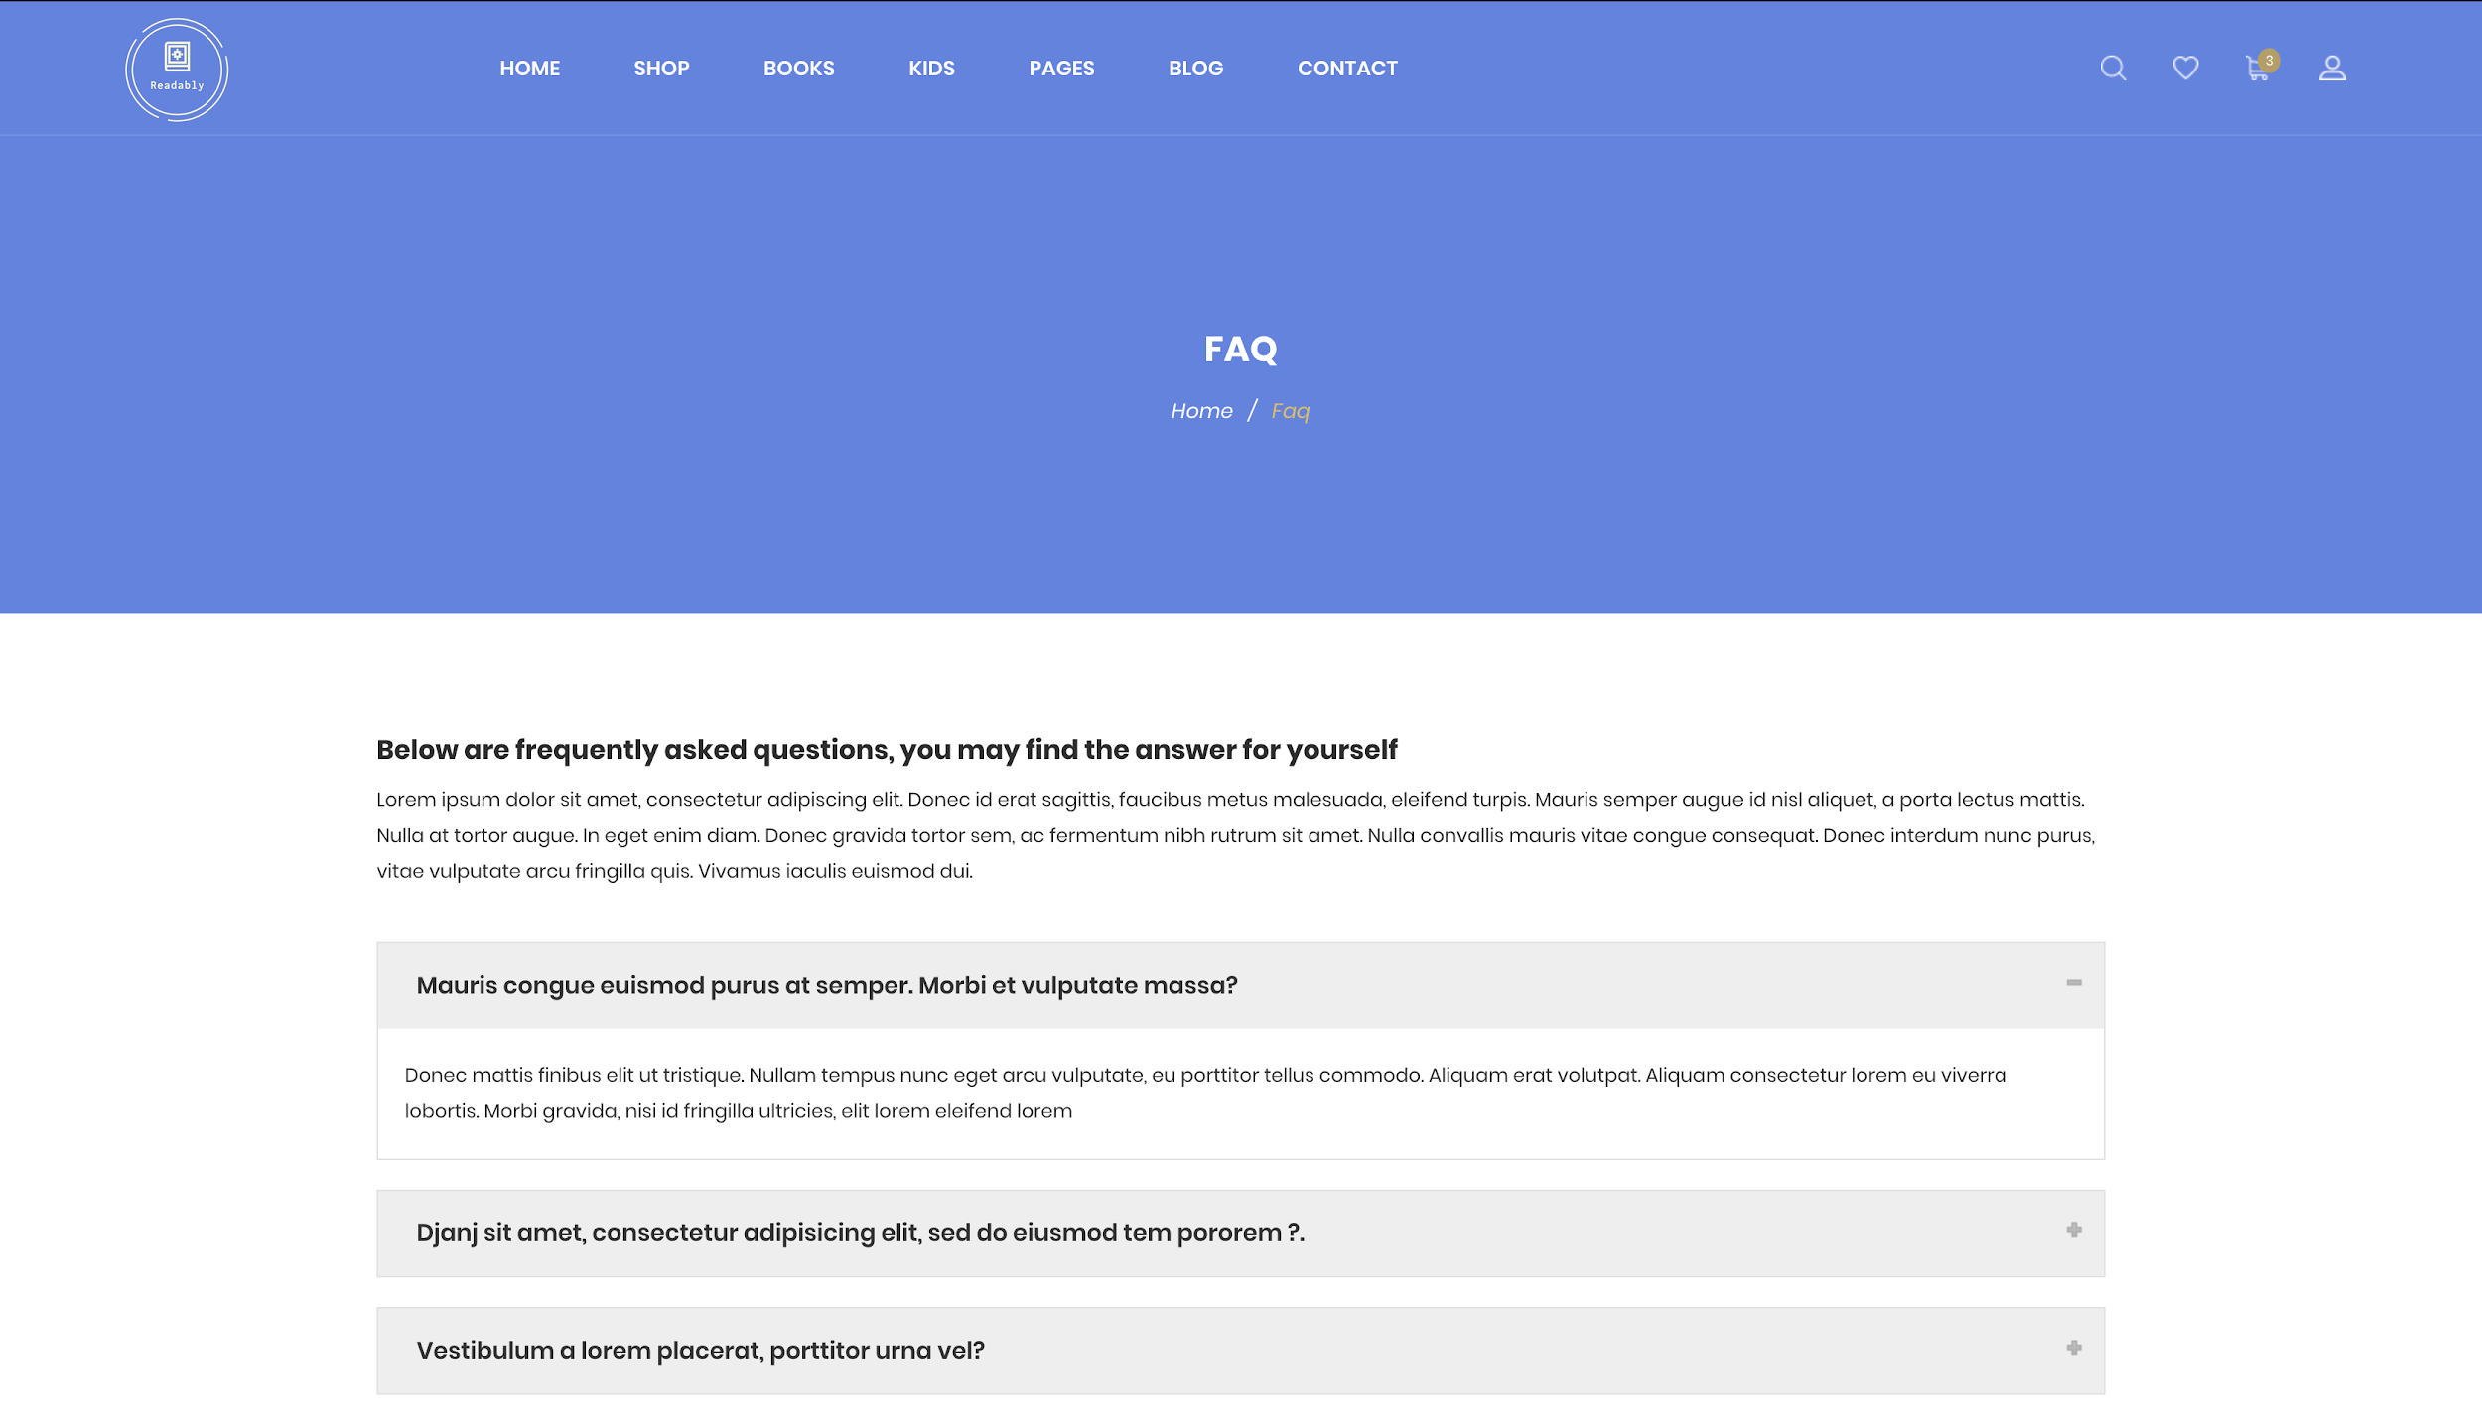

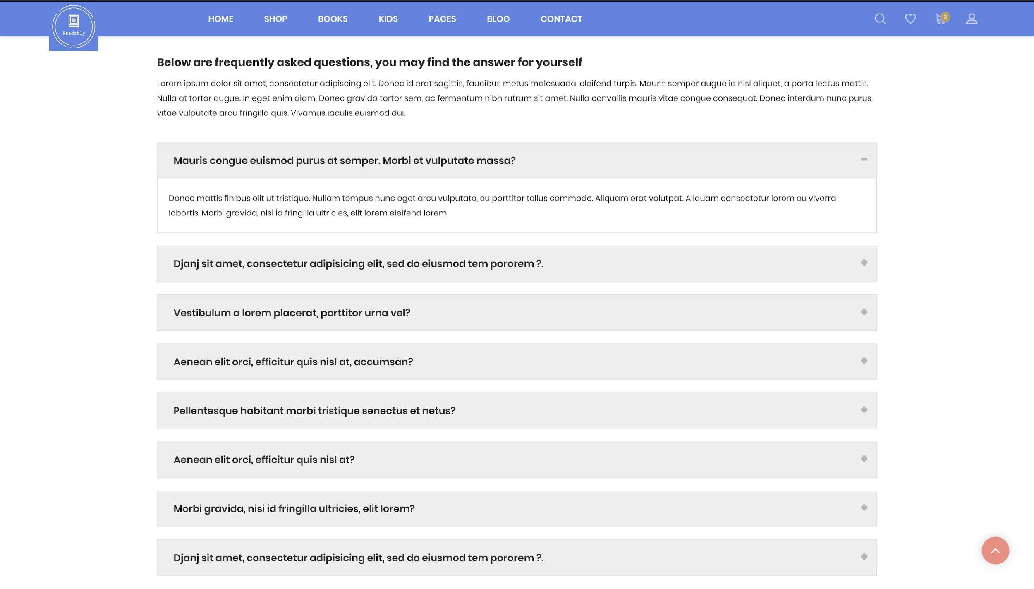

**User Interface/Report Number: 007**

**Related Use-Case: OBS-UC-007(Search/view Books)**



**Shop Grid Page**

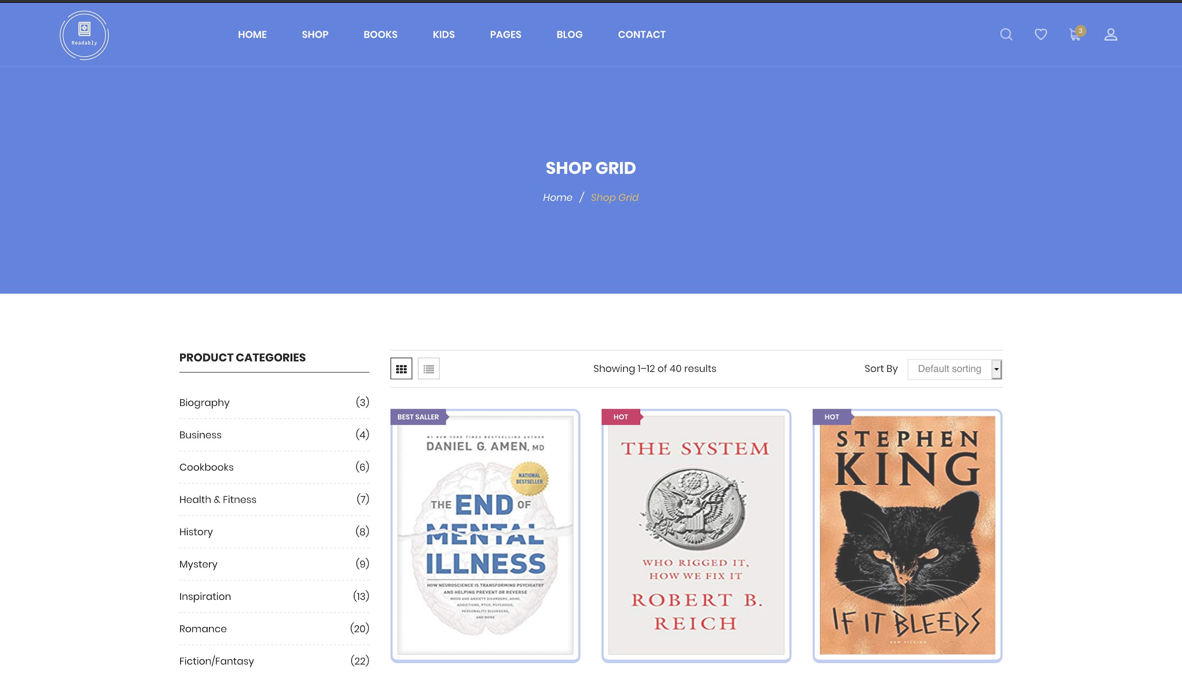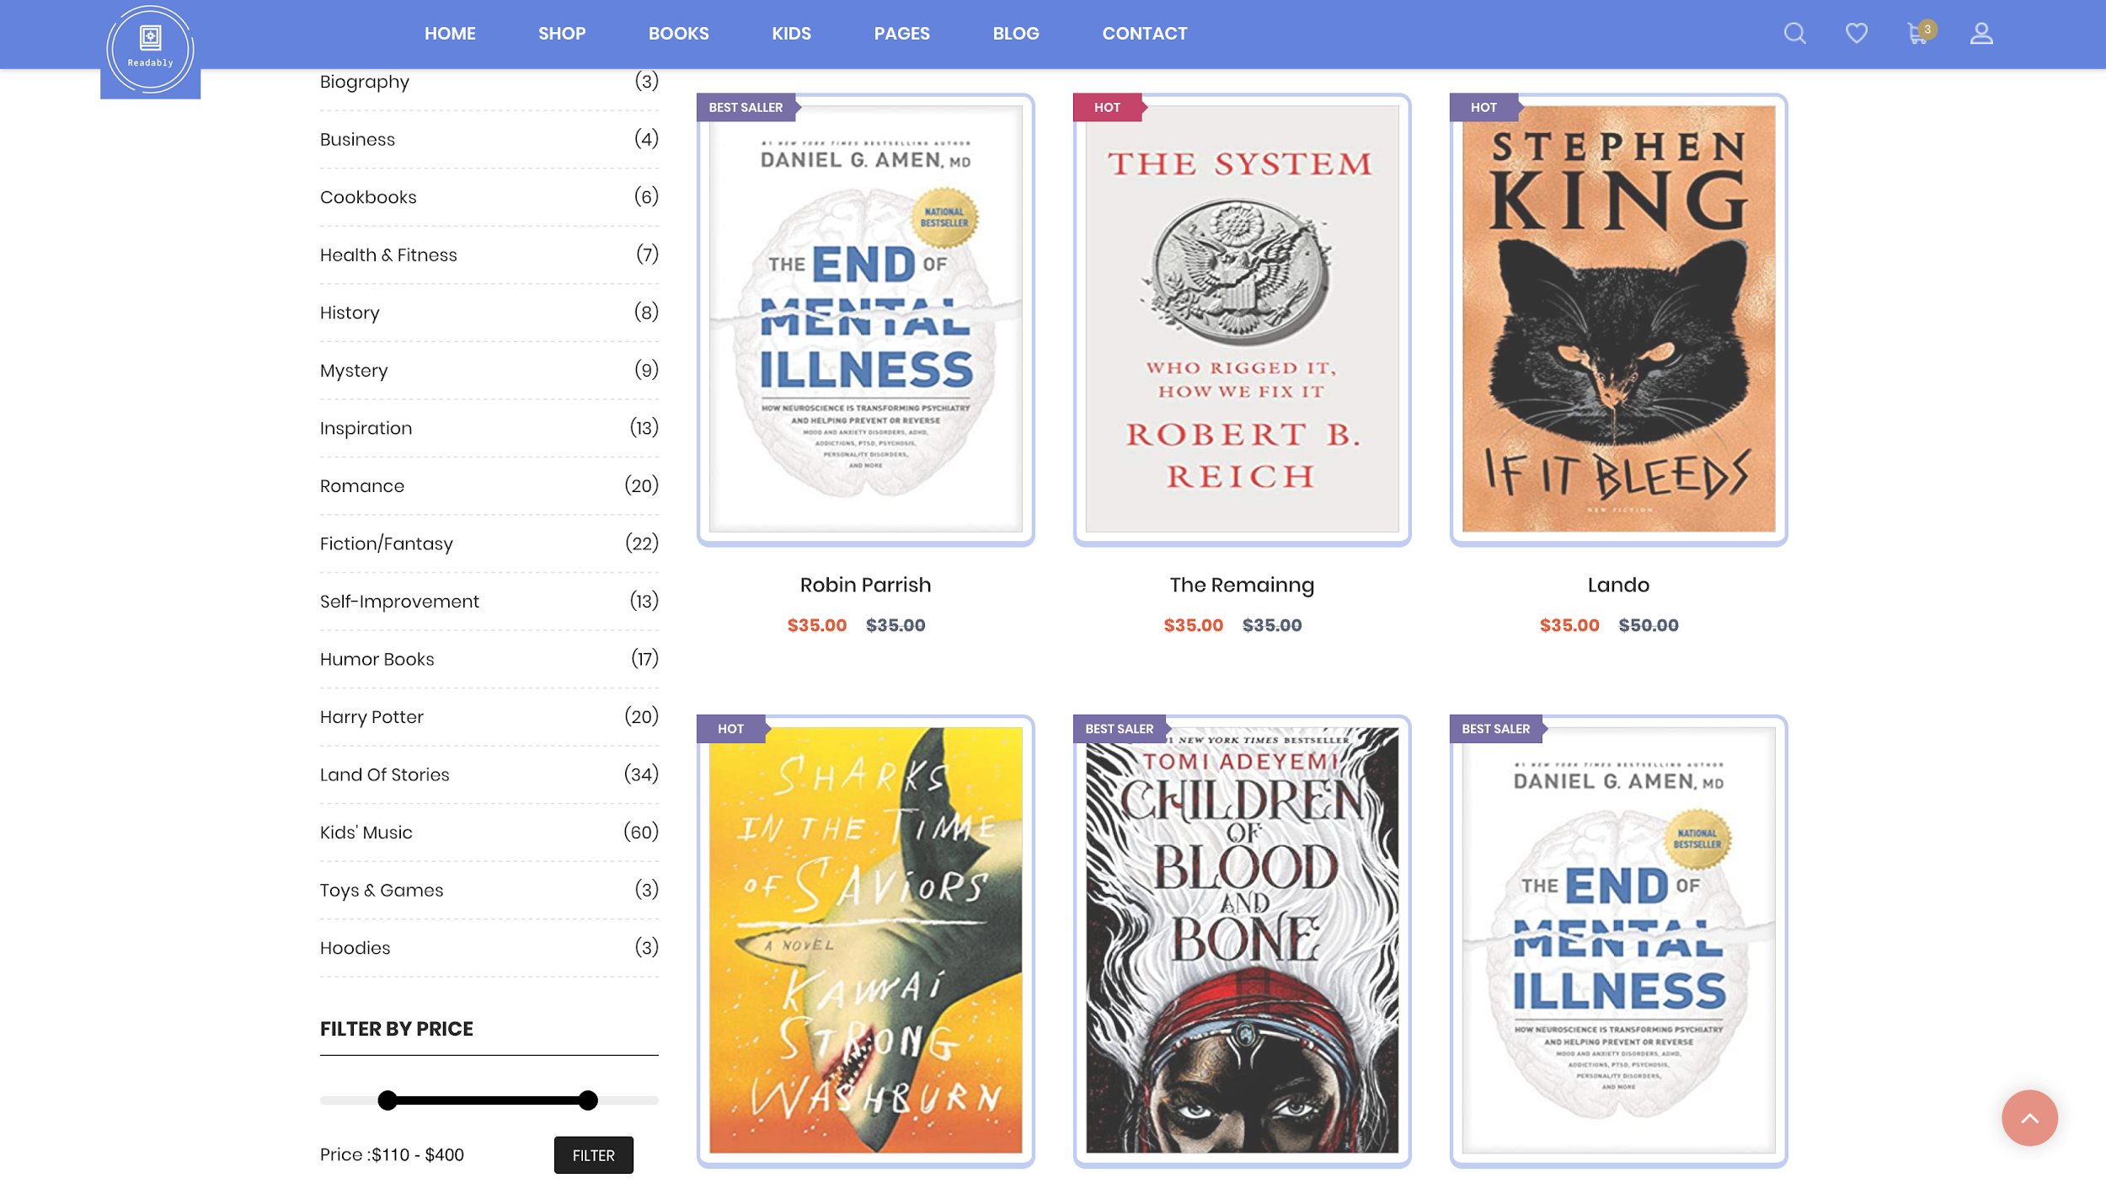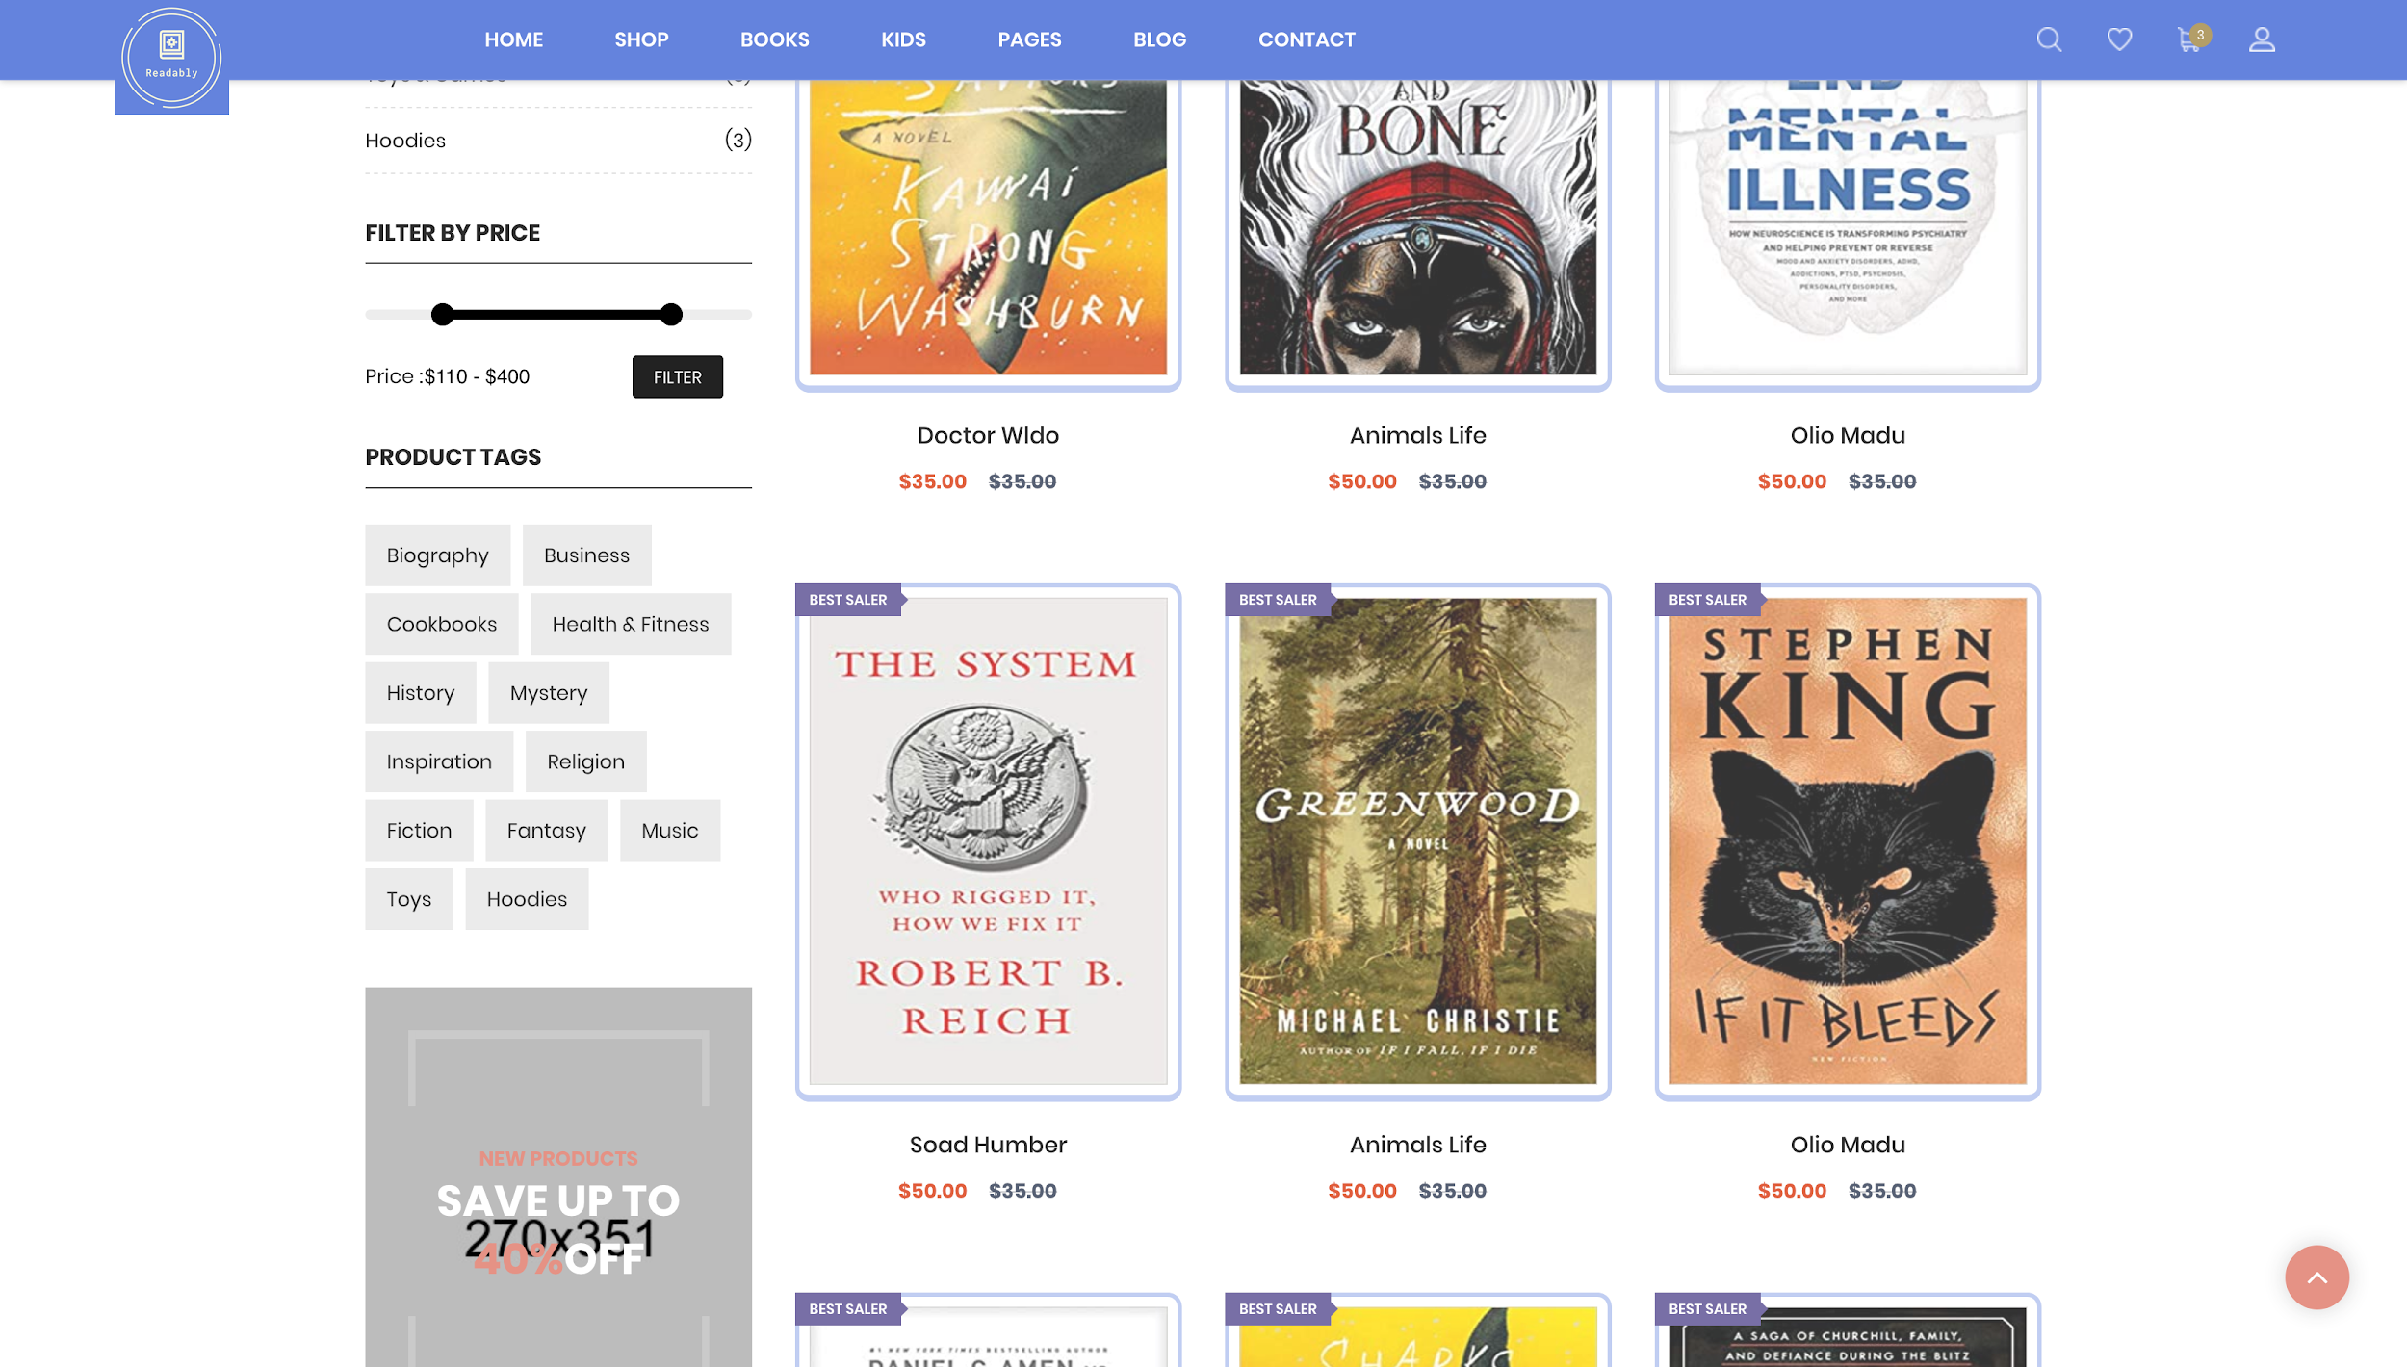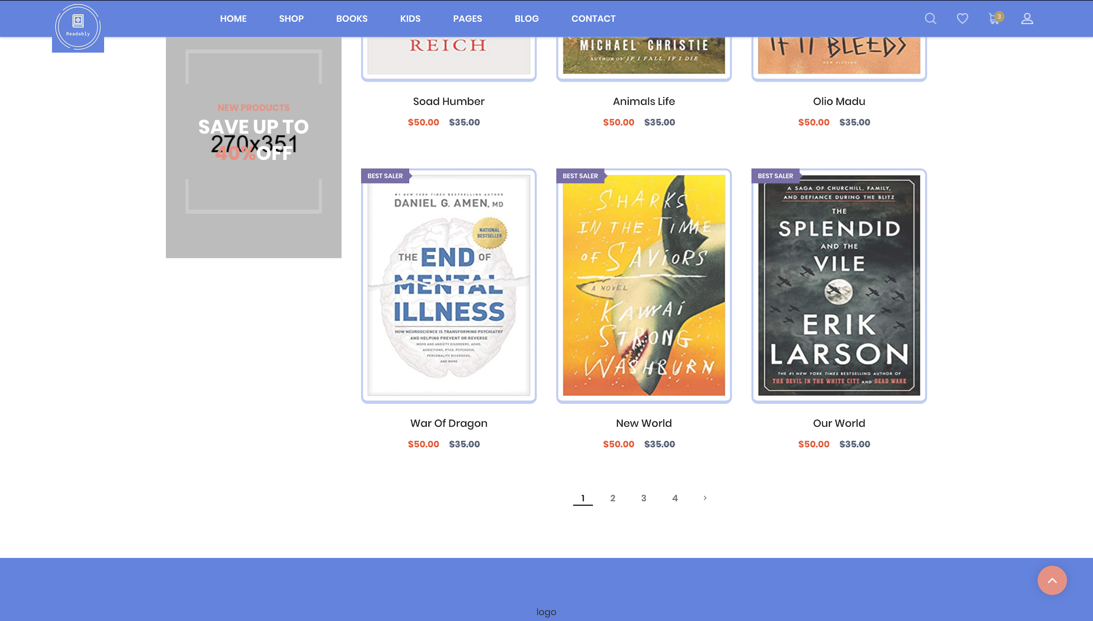

**User Interface/Report Number: 008**

**Related Use-Case: OBS-UC-007 (Search/view Books)**



**Book Description Page**

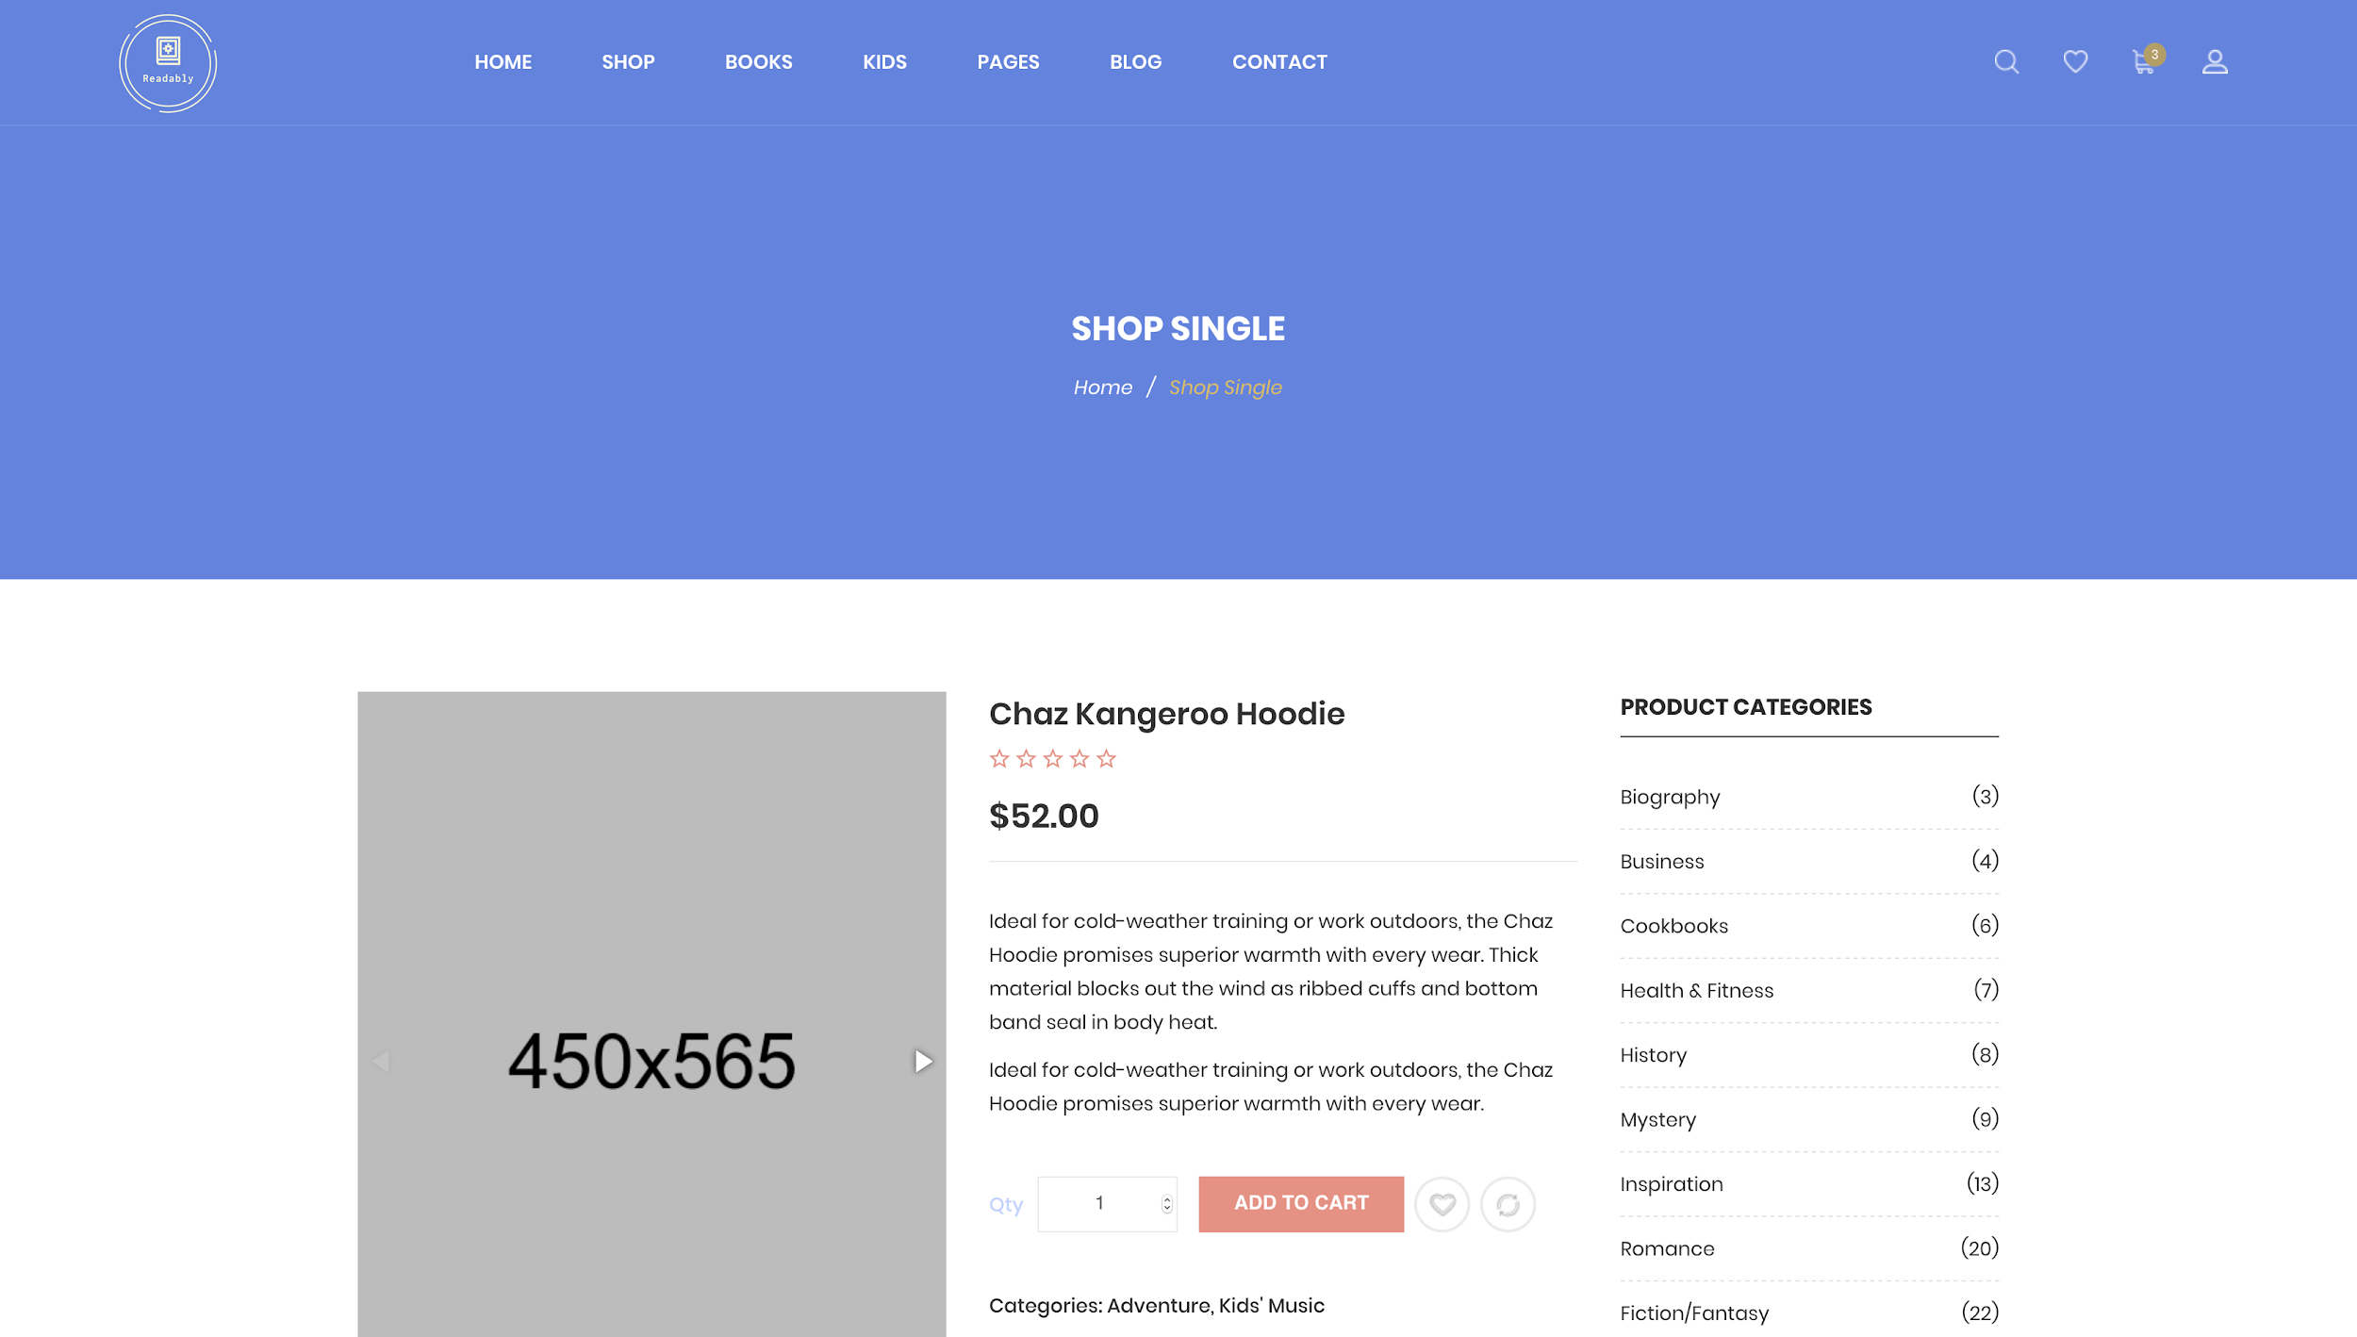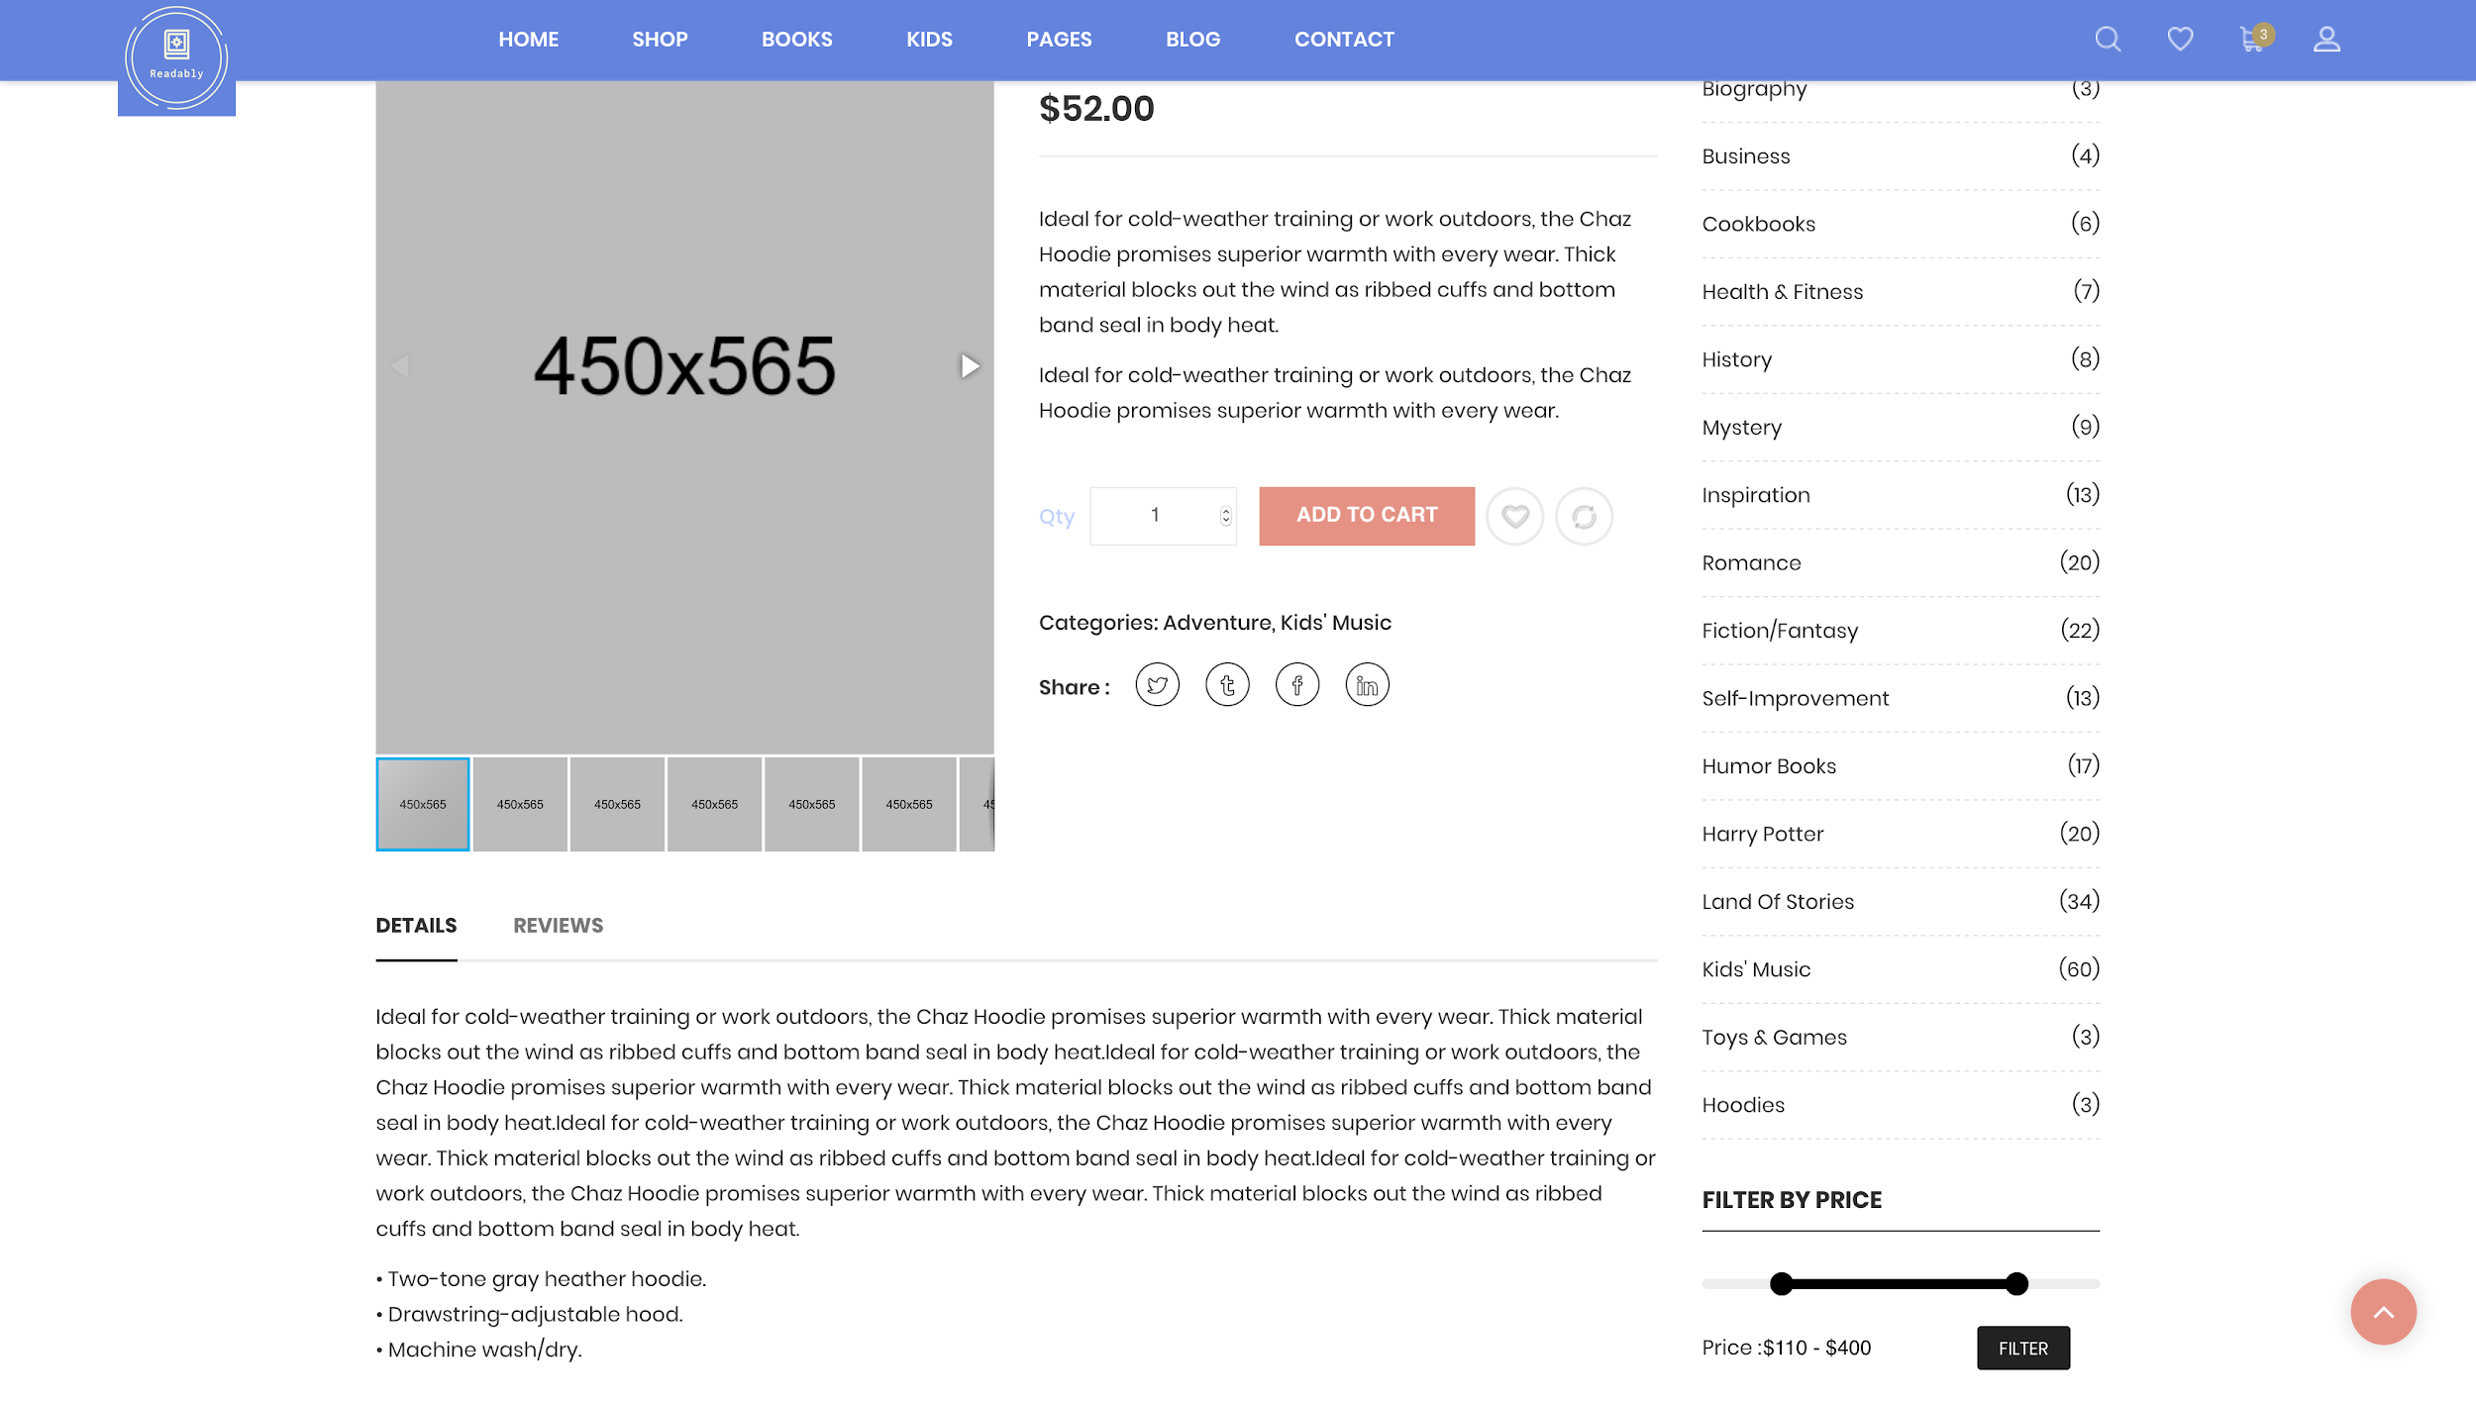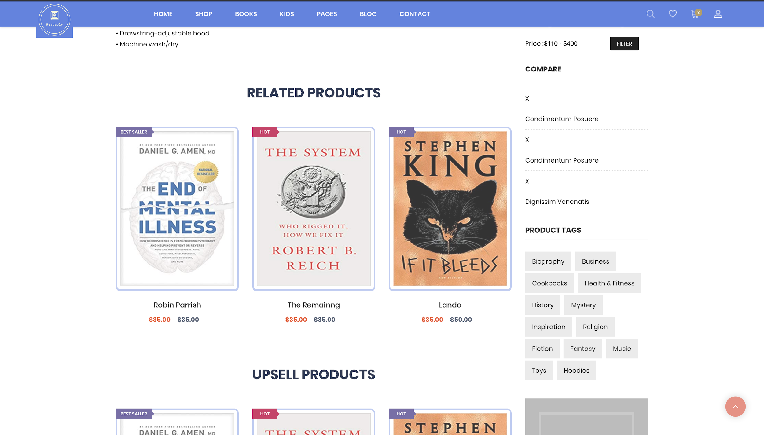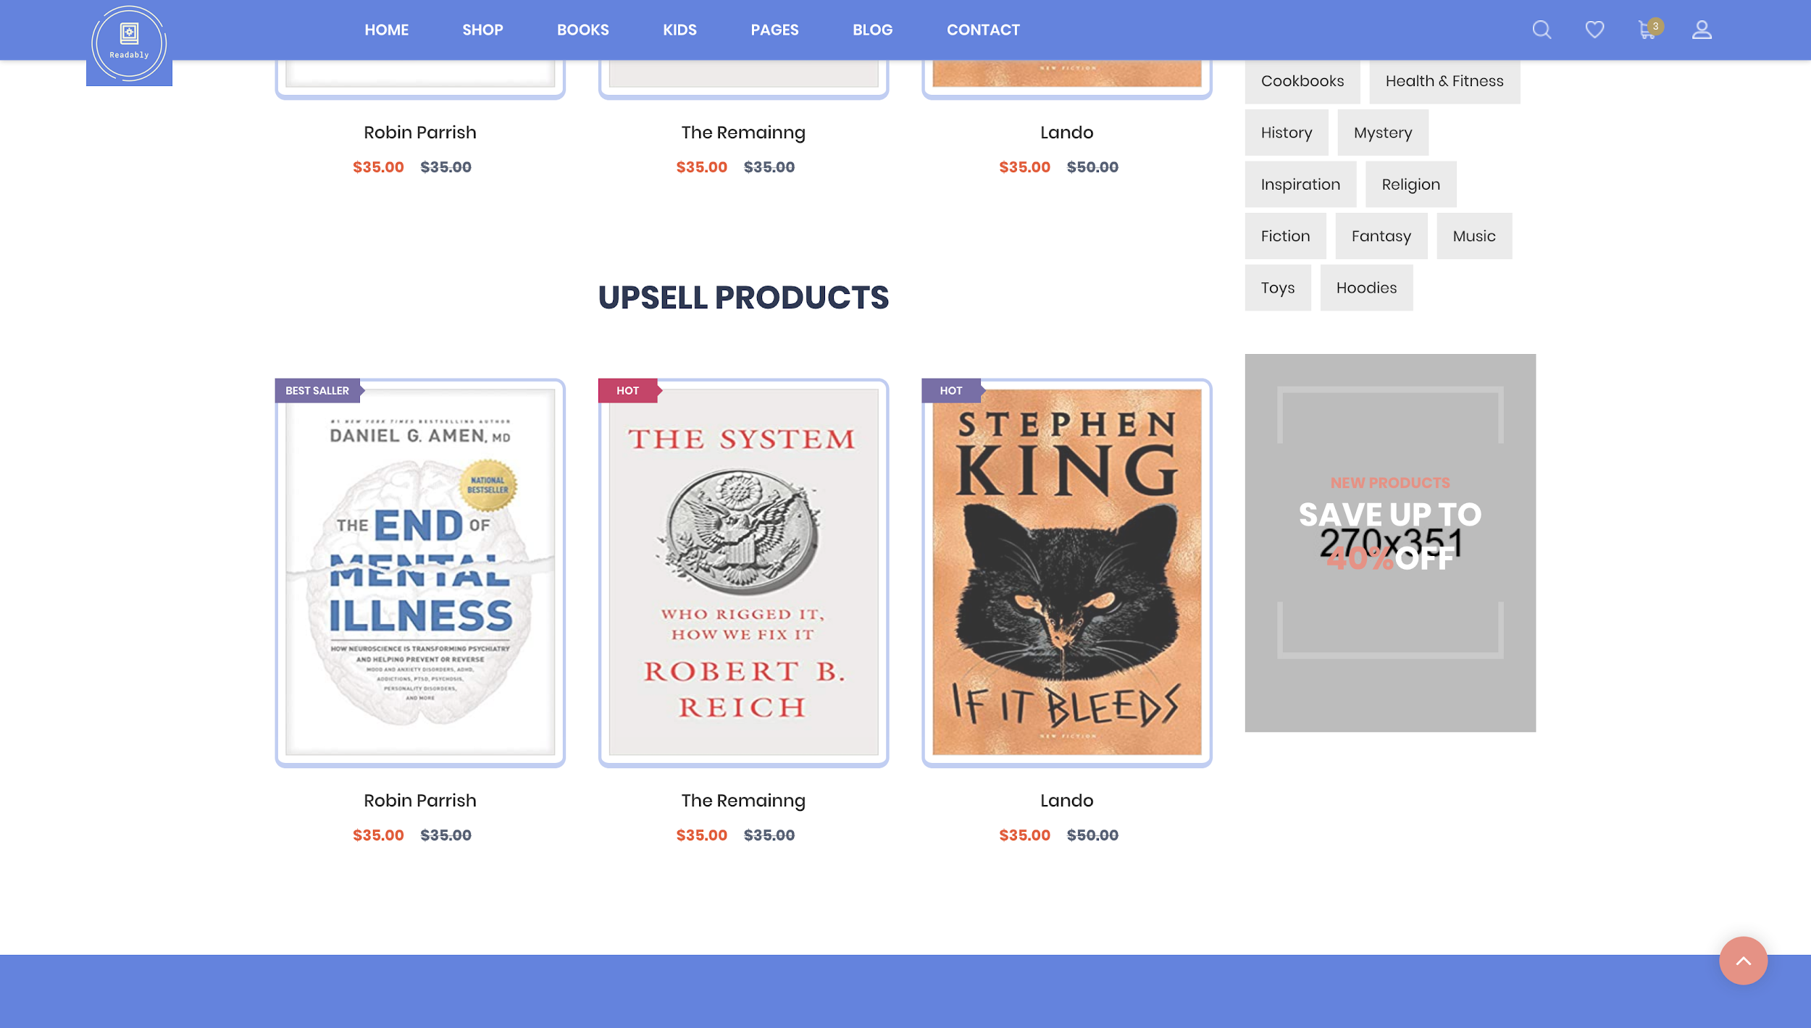

**User Interface/Report Number: 009**



**Team Page**

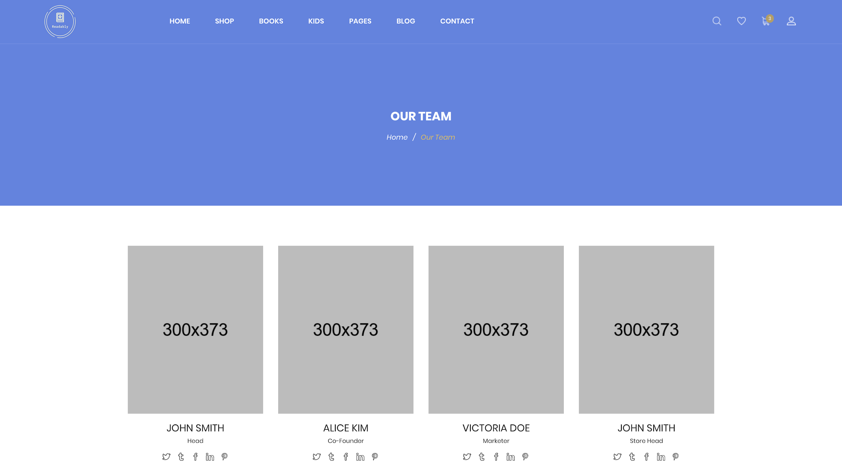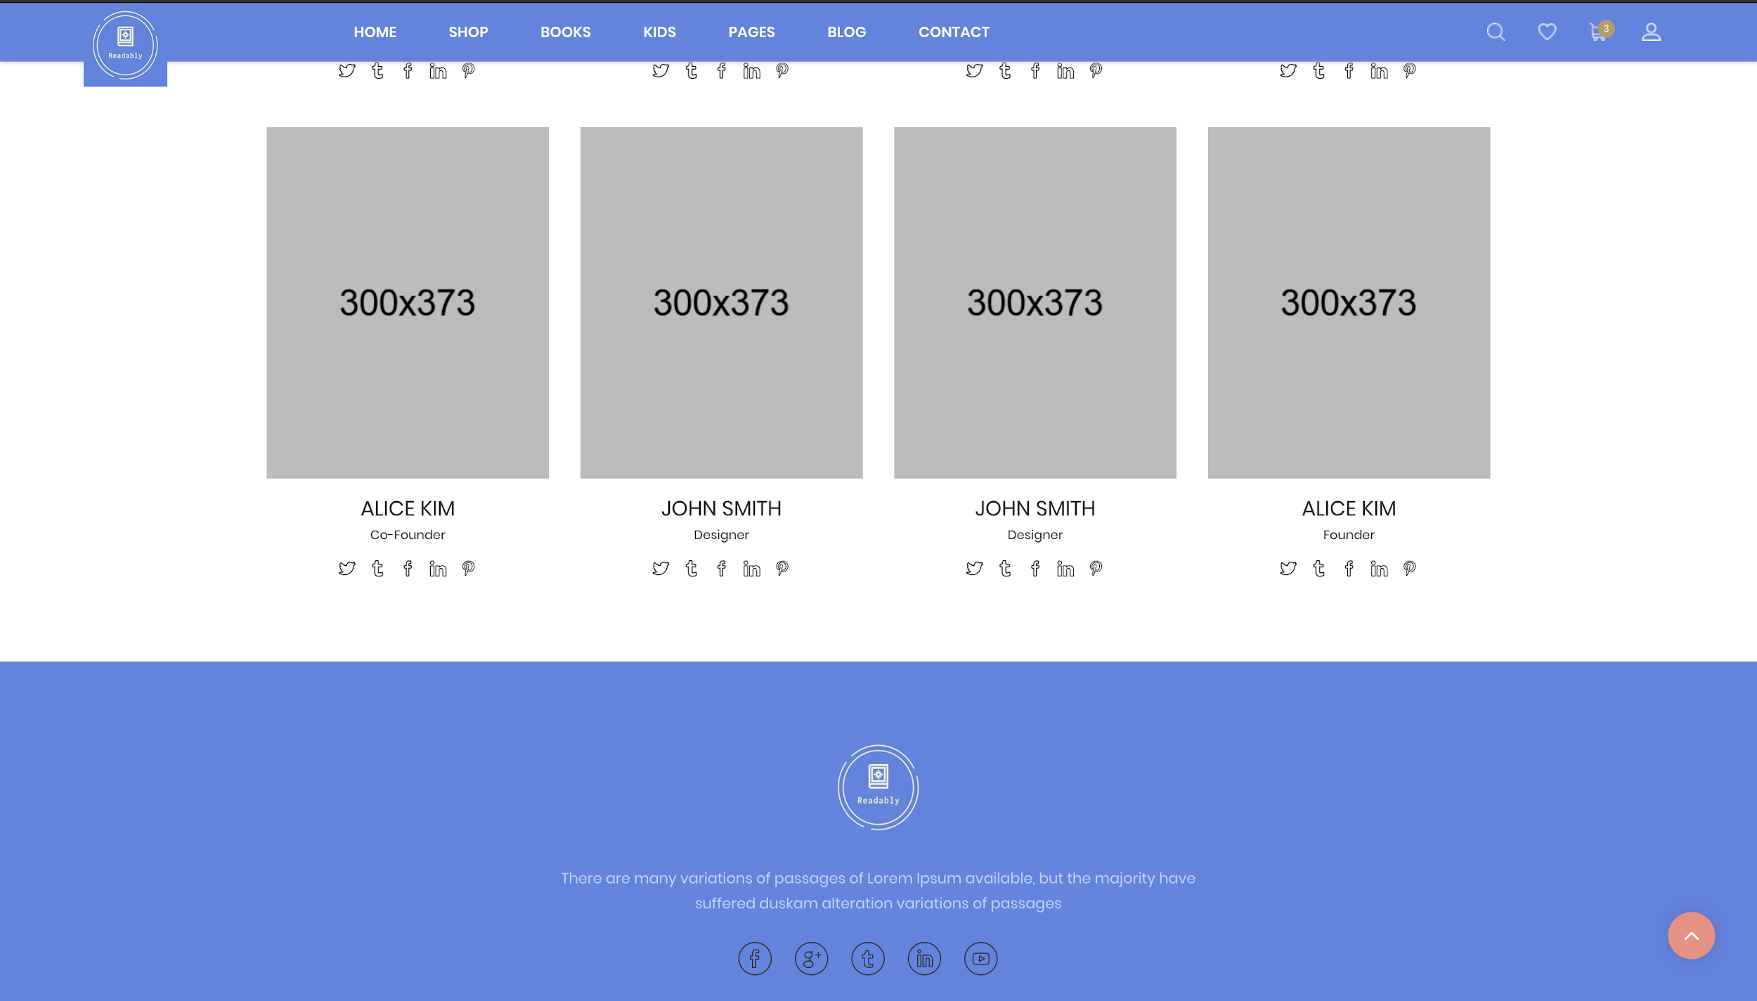

**User Interface/Report Number: 010**

**Related Use-Case:OBS-UC-013(Best Sellers)**



**Wishlist Page**

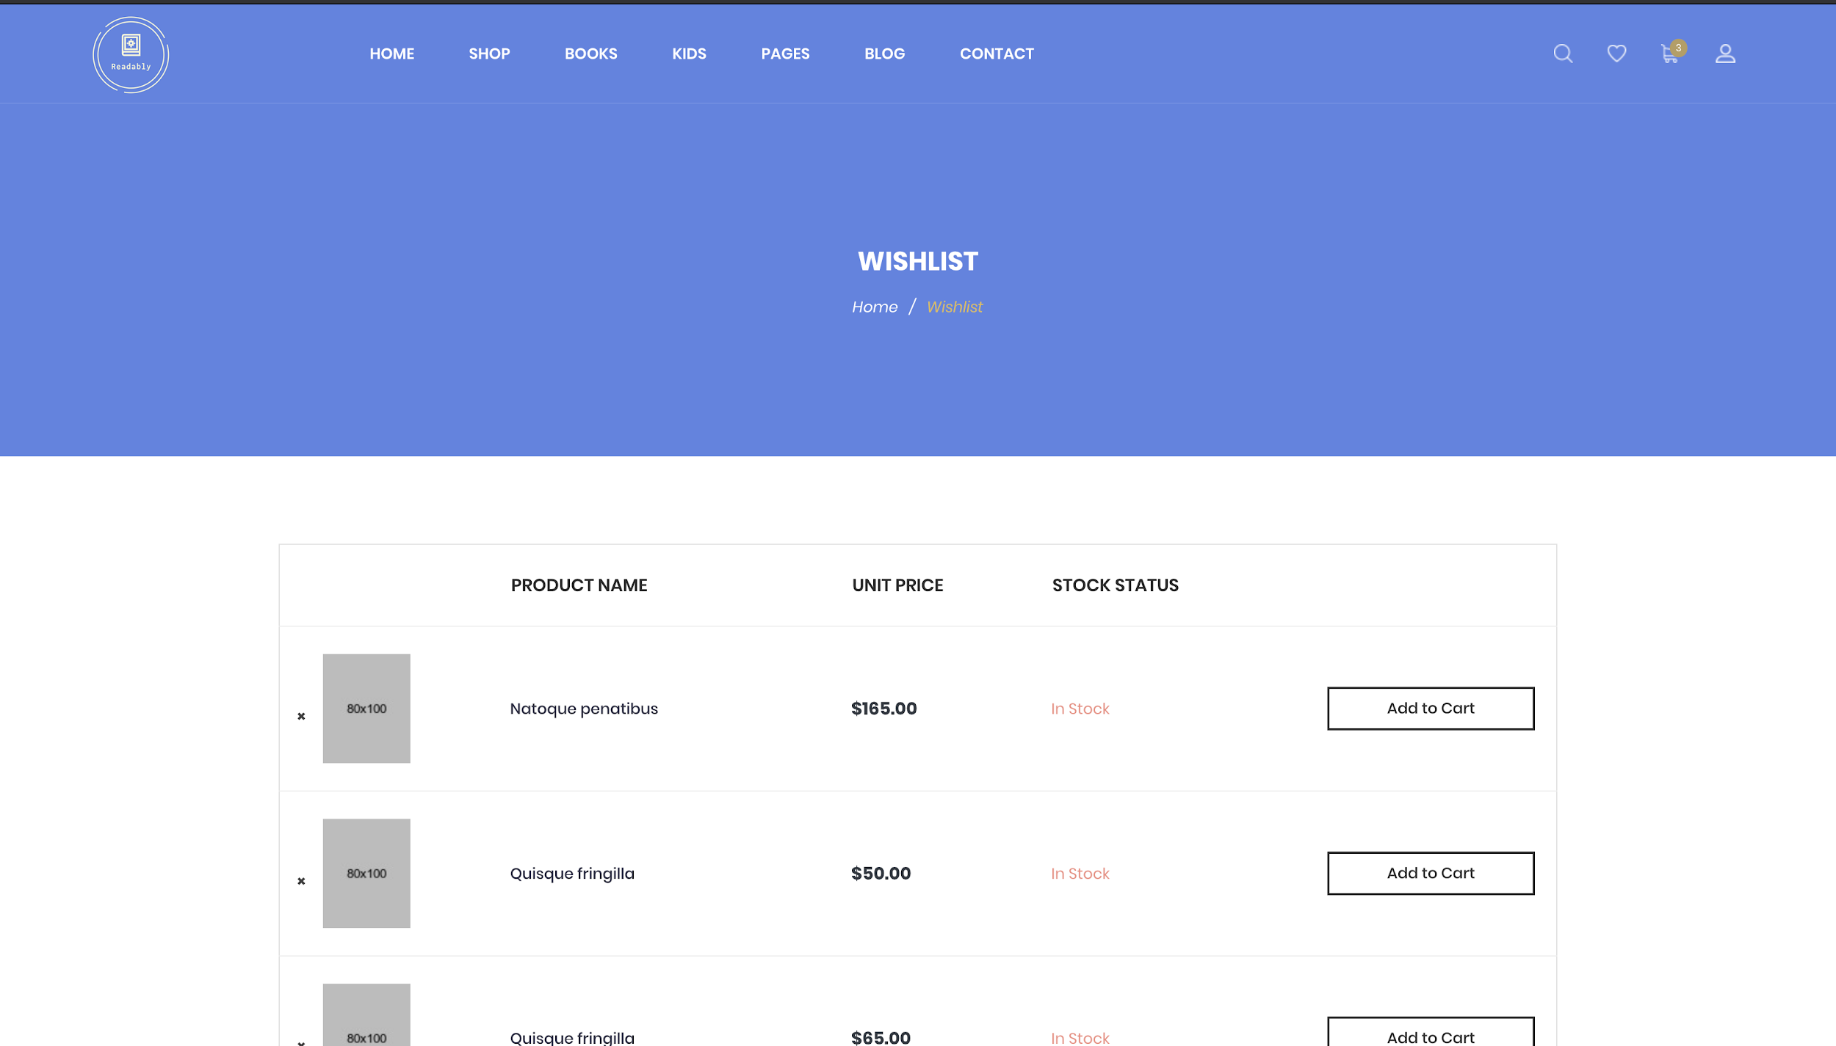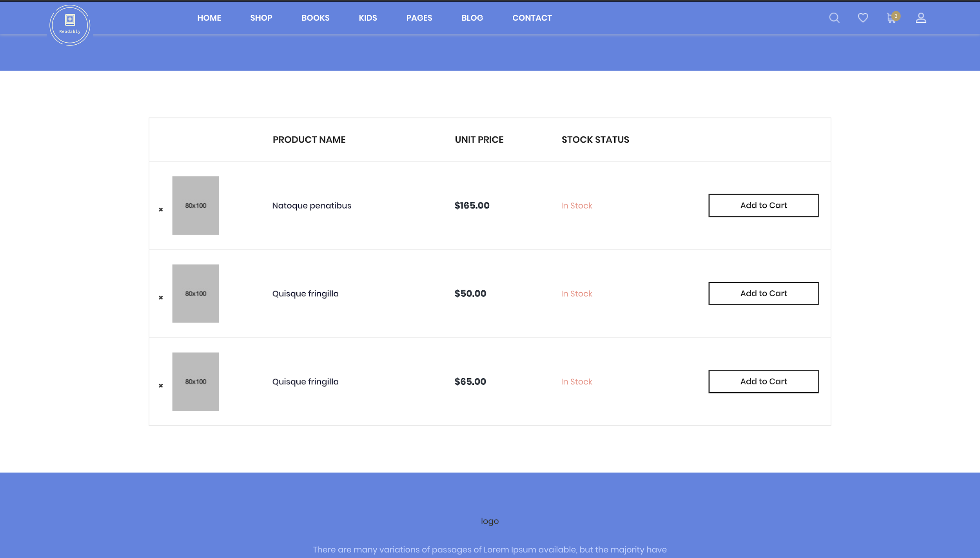

**User Interface/Report Number: 011**

**Related Use-Case: OBS-UC-001(Login)**



**Admin Login Page**

